**Letchworth Library Visual Story**

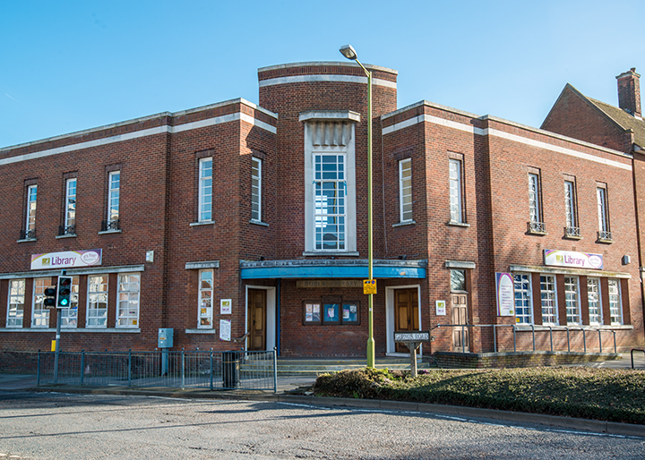

**Letchworth Library, Broadway, Letchworth, SG6 3PF**

**Opening Hours:**

|  |  |  |  |
| --- | --- | --- | --- |
| Monday | 10.00am | - | 6.00pm |
| Tuesday | •1.00pm | - | 🕖7.00pm |
| Wednesday | 10.00am | - | 6.00pm |
| Thursday | Closed |  |  |
| Friday | 10.00am | - | 6.00pm |
| Saturday | 10.00am | - | 5.00pm |
| Sunday | Closed |  |  |

This is a simple guide to help people visiting Letchworth Library for the first time, if you have any questions, please ask the staff.

|  |  |
| --- | --- |
| Image result for letchworth library | This is Letchworth Library   |
| **large desk with computers. A sign on the wall behind says enquiries** | This is the help desk.    Ask here if you need help or have any questions.  If it is busy you may need to queue. |

|  |  |
| --- | --- |
| cid:7dba1184-1fa5-4d9d-a35b-ba2c55aacdf7@Hertfordshire.gov.uk | Library staff are here to help.  All library staff wear a badge like this.   |
| **headphones** | Sometimes we have noisy times in the library and you may wish to visit at a quieter time.    Or you can bring some ear defenders with you to wear. |

|  |  |
| --- | --- |
| **library cards front and back** | This is a library card, you will get one when you become a library member.    You need a library card to borrow books and DVDs and to use the computers.  To get a library card, ask the staff at the help desk. |
| pink self service kiosk | This is a kiosk. You can borrow and return books here.    Follow the instructions on the screen. Ask the library staff if you need help.  If it is busy you may need to queue. |
| inside space with children's table and chairs on the left, a sofa, wooden boxes with picture books and book shelves on the wall on the right | This is the Children’s area.   |
| a small area with book shelves on the left and a sofa on the right | This is the Teenage area.   |
| **large open space with self service kiosks on the left and right and book display units in the middle** | There are lots of books you can borrow.    If you cannot find a book you are looking for, you can ask the library staff to help. |
| A shelf with magazines on it | You can also borrow magazines and books you can listen to on CD.   |
| cid:cd222469-9e3d-470a-9d14-30fc23d970b8@Hertfordshire.gov.uk | These are the computers. They are downstairs. Library members can use them for free for two hours a day.    If the computers are busy you may need to book.  Ask the library staff if you need help. |
| small room with square table and chairs around it | This is the quiet study area. There is free Wi-Fi in the library.   wifi logo  Desks with power sockets are available.  You can charge your own device here. |
| cid:e43681d1-e20f-4615-8f86-7795d43b3938@Hertfordshire.gov.uk | When you are ready to leave the library, take the things that you want to borrow to the kiosk and follow the instructions on the screen. Ask the library staff if you need help.  If it is busy you may need to queue.   |

|  |  |
| --- | --- |
| cid:4c311b1f-8343-42b0-8ecf-9e181c4cca5d@Hertfordshire.gov.uk | You can take the things you have borrowed home. Print a receipt so you know when you need to bring them back to the library.    Remember to return or renew your items on time to avoid charges.  You can renew your items at the kiosk or:   * ask at the desk * online at [www.hertfordshire.gov.uk/libraries](http://www.hertfordshire.gov.uk/libraries) * Telephone: 0300 123 4049 * Textphone: 0300 123 4041 |
| cid:38b11f0d-3e1d-4975-99eb-d73f8a421c04@Hertfordshire.gov.uk | We hope you enjoyed the story.  If you need any extra help or information please ask a member of staff.     For more information on the library please visit our website:  [www.hertfordshire.gov.uk/letchworthlibrary](https://www.hertfordshire.gov.uk/letchworthlibrary)  Please come back soon. ☺ |