**Rickmansworth Library Visual Story**

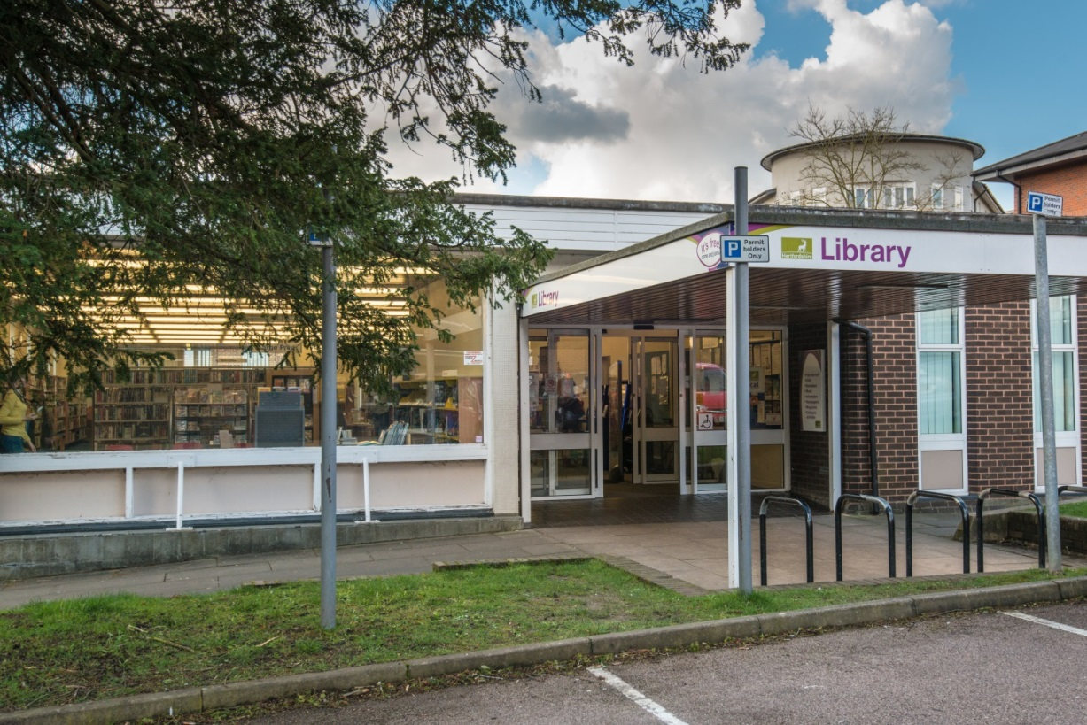

**Rickmansworth Library, High Street, Rickmansworth, WD3 1EH**

**Opening Hours:**

|  |  |  |  |
| --- | --- | --- | --- |
| Monday | 9.30am | - | 6.00pm |
| Tuesday | 9.30am | - | 6.00pm |
| Wednesday | Closed |  |  |
| Thursday | 9.30am | - | 6.00pm |
| Friday | •1.00pm | - | 6.00pm |
| Saturday | 9.30am | - | 4.00pm |
| Sunday | Closed |  |  |

This is a simple guide to help people visiting Rickmansworth Library for the first time, if you have any questions please ask the staff.

|  |  |
| --- | --- |
| outside front entrance of library | This is Rickmansworth library   |
| help desk with perspex screens | This is the help desk. Ask here if you need help or have any questions.    If it is busy you may need to queue. |
| member of staff showing her badge | Library staff are here to help. All library staff wear a badge like this.   |

|  |  |
| --- | --- |
| **headphones** | Sometimes we have noisy times in the library and you may wish to visit at a quieter time.    Or you can bring some ear defenders to wear. |

|  |  |
| --- | --- |
| **library card** | This is a library card, you will get one when you become a library member.    You need a library card to borrow books and magazines and to use the computers.  To get a library card, ask the staff at the help desk. |
| self service touchscreen kiosk | This is a kiosk. You can borrow and return books here.    Follow the instructions on the screen. Ask the library staff if you need help.  If it is busy you may need to queue. |
| children library with large carpet, book shelves on the wall and display boxes of picture books | This is the children’s area.   |
| rows of shelves filled with books | There are lots of books you can borrow.   |

|  |  |
| --- | --- |
| A shelf with a variety of magazines | You can also borrow magazines   |
| A table with a computers on it | These are the computers. Library members can use them for free for one hour a day.    If the computers are busy you may need to book. Ask the library staff if you need help. |
| person sitting at a desk | This is the quiet study area. There is free Wi-Fi in the library.   wifi logo  Ask staff for login details. |
| book in self service kiosk with hand scanning library card | When you are ready to leave the library, take the things that you want to borrow to the kiosk and follow the instructions on the screen. Ask the library staff if you need help.    If it is busy you may need to queue. |
| receipt coming out of self service kiosk | You can take the things you have borrowed home. Print a receipt so you know when you need to bring them back to the library.  Remember to return or renew your items on time to avoid charges.  You can renew your items at the kiosk or:   * ask at the desk * online at [www.hertfordshire.gov.uk/libraries](http://www.hertfordshire.gov.uk/libraries) * Telephone: 0300 123 4049 * Textphone: 0300 123 4041 |
| lady putting books in bag | We hope you enjoyed the story.  If you need any extra help or information please ask a member of staff.     For more information on the library please visit our website:  [www.hertfordshire.gov.uk/rickmansworthlibrary](https://www.hertfordshire.gov.uk/rickmansworthlibrary)  Please come back soon. ☺ |