**Waltham Cross Library Visual Story**

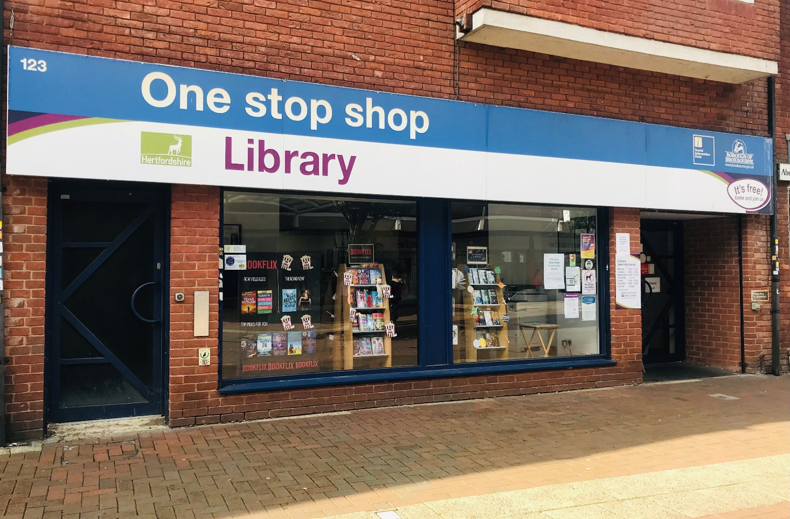

123 High Street, Waltham Cross, EN8 7AN

|  |  |
| --- | --- |
| Monday | 9.00am – 5.30pm |
| Tuesday | 9.00am – 5.30pm |
| Wednesday | 9.00am – 5.30pm |
| Thursday | CLOSED |
| Friday | 9.00am – 5.30pm |
| Saturday | 9.00am – 1.00pm |
| Sunday | CLOSED |

Opening Hours:

This is a simple guide to help people visiting Waltham Cross Library for the first time, if you have any questions please ask the staff.

|  |  |
| --- | --- |
| outside front entrance with large shop window. A large sign above the window saying Library | 👈This Waltham Cross Library. |

|  |  |
| --- | --- |
| A person sitting at a desk using a computer | 👈 This is the help desk. Ask here if you need help or have any questions.  If it is busy you may need to queue. |
| A person with a staff badge standing in front of a bookshelf | 👈 Library staff are here to help. All library staff wear a badge like this. |

|  |  |
| --- | --- |
| headphones | 👈 Sometimes we have noisy times in the library, and you may wish to visit at a quieter time.  Or you can bring some ear defenders to wear. |
| library card front and back | 👈 This is a library card; you will get one when you become a library member.  You need a library card to borrow books, magazines, audiobooks and to use the computers.  To get a library card, ask the staff at the help desk. |

|  |  |
| --- | --- |
| pink self service kiosk | 👈 This is a kiosk. You can borrow and return books here.  Follow the instructions on the screen. Ask the library staff if you need help.  If it is busy you may need to queue. |
| library with 5 computers on the left, a table and chairs in the middle and rows of bookshelves on the back and right | 👈 This is the main library area. |
| rows of bookshelves | 👈 There are lots of books you can borrow. |

|  |  |
| --- | --- |
| shelves with children's books and a wooden box with picture books on the floor | 👈 This is the children’s area. |
| magazines on a table | 👈 You can borrow magazines. |
| shelves with audiobooks | 👈 There are also audio books you can borrow.  These are recordings on CD of a book being read. |
| desk with computers | 👈 These are the computers. Library members can use them for free for two hours a day.  If the computers are busy you may need to book. Ask the library staff if you need help. |

|  |  |
| --- | --- |
| table with 2 chairs | 👈 This is the quiet study area. There is free Wi-Fi in the library.  wifi logo  Ask staff for login details. |
| leaflet called charges and concessions | We charge for some library services.  👈 Please ask staff for more information or for a leaflet. |
| a hand holding a library card at a self service kiosk | 👈 When you are ready to leave the library, take the things that you want to borrow to the kiosk and follow the instructions on the screen. Ask the library staff if you need help.  If it is busy you may need to queue. |

|  |  |
| --- | --- |
| hand taking a receipt from self service kiosk | You can take the things you have borrowed home. Print a receipt so you know when you need to bring them back to the library.  Remember to return or renew your items on time to avoid charges.  You can renew your items at the kiosk or:   * ask at the desk * online at: [www.hertfordshire.gov.uk/libraries](http://www.hertfordshire.gov.uk/libraries) * Telephone: 0300 123 4049 * Textphone: 0300 123 4041 |

|  |  |
| --- | --- |
| someone putting books in a bag | We hope you enjoyed the story.  If you need any extra help or information, please ask a member of staff. 👍  For more information on the library please visit our website:  [www.hertfordshire.gov.uk/walthamcrosslibrary](https://www.hertfordshire.gov.uk/walthamcrosslibrary)  Please come back soon. 😊 |