Annual Health Check Preparation Form

- This form helps to prepare a person with a learning disability aged 14 and over for their Annual Health Check and make sure that you can plan the important things to be talked about at the appointment

- If you are filling this in for yourself, please ask someone who knows you well to help you. This is because they may have spotted changes in you that you haven’t spotted yourself.

- If you are someone who knows the person well and are completing this for them, please involve the person as much as possible to empower them to be aware of their own health.

- When it is complete, please return it to their GP surgery if they have requested it OR take it to the appointment so you can tell them what you feel is important to talk about

- Please Also use the Stay Healthy at Home Checklist

Name and Address:
___________________________________________________________
Name of person helping you and who are they to you:
___________________________________________________________
Contact details of that person:
___________________________________________________________
Date of last annual health check (if known):

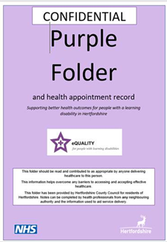The Purple Folder is a Hertfordshire  health passport | Do you have a NEW 2023 Purple Folder? Yes No  If Yes, please bring it to the annual health check appointment and make sure it is up to date.  If No email purplefolder@hertfordshire.gov.uk  We also now have Purple Cards for people who are likely to go out and about on their own that you can ask for.  Purple Folders are for People aged 18 and over. If you are aged 14-17 you can use the My Health Information Document on the SEND web pages Caring for your health into adulthood (hertfordshire.gov.uk)
 | Tell us the best way to communicate with you at appointments – Do you need any Reasonable adjustments to help you? What can we do, say or talk about that will help you relax? Is there anything we must NOT do or say? Do you need extra Time or a different place to be seen? Tell us anything we can do to help you accept health care from us.
 | Tell us the best way for the surgery to contact you for health appointments in the future. Do you prefer letters, texts or phone calls? Do you avoid going to the doctors because you don’t have anyone to help you? What could we do to help?
 | Tell us about the accommodation you live in? Who do you live with? What help do you have at home?
   | Tell us about work or daily activities, clubs or services that you attend or what else you do with your days
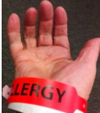 | Are you allergic to anything? What is it and what happens if you have it?
 | Do you have a known cause of your learning disability or diagnosis e.g. Down’s syndrome?
 | Do you have any known health conditions e.g., epilepsy?
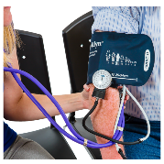  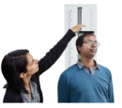 | What is your  Height: Blood pressure (if known):  Weight: Waist circumference (if known):  Date last checked:
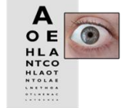 | Do you have any problems with your eyes? Has anything changed this year?  When did you last attend an appointment at an optician?
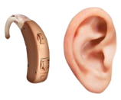 | Do you have problems with your ears or hearing? Do you wear a hearing aid? Have you noticed any changes this year?  Have you seen an audiologist (health professional who checks your ears)? When?
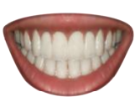 | Do you have any problems with your teeth or mouth or with brushing your teeth?  When did you last go to the dentist?
 | Do you have any difficulty swallowing? e.g., chewing for a long time or coughing after eating?  Are you under the care of a Speech and Language Therapist for this (SALT)?
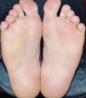 | Do you have any problems with your feet or toenails? Do you wear any specialist shoes or splints?  Are you under a chiropodist/podiatrist? When did you last see them?
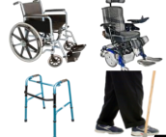 | Tell us about your mobility. Have you noticed any changes in your ability to walk or move? Do you use any mobility aids e.g., wheelchair or walking stick? Tell us about any falls you have had.  Do you see a physiotherapist? When did you last see them and what do they do for you?
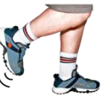 | Tell us about what you do to stay fit and well.
 | If you have seen an occupational therapist, tell us when and what they did for you?
 | Tell us about your diet. Tell us everything you ate and drank yesterday.
 | If you drink alcohol tell us what you drink, how much and how often?
 | If you smoke or vape, tell us how many a day.
 | If you take recreational drugs e.g., cannabis? tell us what you take and how often.
 | If you take any other medication that is not prescribed by your GP e.g. over-the-counter pain killers? Tell us what you take and how often.
 | If you are someone who has sex or sexual contact with other people tell us what you know about safe sex  Do you use any contraceptives?
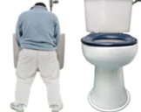 | Tell us about your wee. How often do you wee and what colour is it? Do you have accidents? Do you use pads? Do you go a lot at night?
 | Tell us about your poo. How often do you poo and what do they look like [are they runny or like a soft sausage or hard lumps]? Do you need to wear pads, or do you ever have accidents? Has your pooing changed at all?
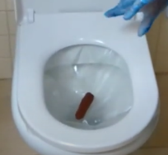 | FOR ANYONE AGED 60 AND OVER:  Have you had the bowel screening kit in the post? When did you complete this? If you didn’t complete it, tell us why?
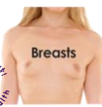    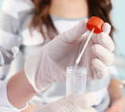 | FOR WOMEN:  Tell us about your periods. How often do you have them? Are they very heavy? Do you get mood changes or bad pain? Have they changed at all? Do you have any signs of menopause?  Tell us about your breasts and armpits. Have you noticed any changes e.g. pain, lumps, swelling. Do you have a family history of breast cancer? Do you keep an eye on/feel for changes in your breasts and armpits every month?  FOR WOMEN 50 and OVER:  Have you had a letter to go to breast screening? Tell us when you went and if you didn’t, why you didn’t go?  FOR WOMEN 25 AND OVER:  Have you had a letter to go to cervical screening? Tell us when you went and if you didn’t, why you didn’t go? Did you have the HPV vaccine at school as this helps reduce risk of cervical cancer
  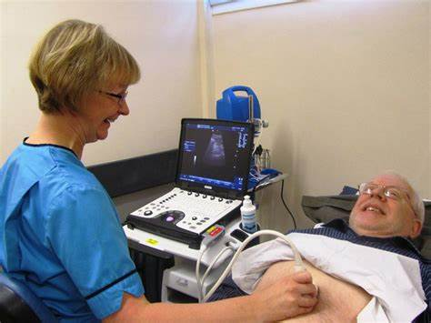  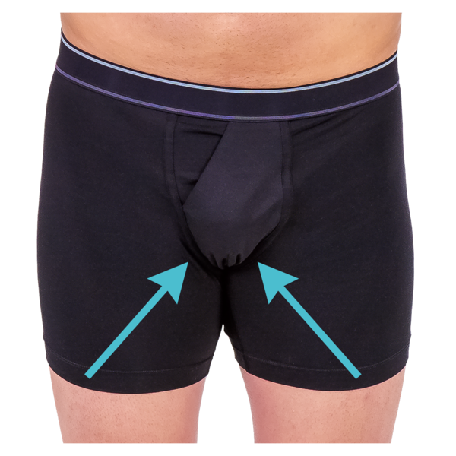 | FOR MEN:  Tell us about your testicles (balls). Have you noticed any changes e.g., pain, lumps, swelling? Do you keep an eye on/feel for changes in your balls every month?  Tell us about your chest and armpits. Have you noticed any changes e.g., pain, lumps, swelling? Do you keep an eye on/feel for changes in your chest and armpits every month?  FOR MEN AGED 65 AND OVER:  Have you had a letter to attend abdominal aortic aneurysm (AAA) screening? Tell us when you went and if not, what were the barriers? Do you have any symptoms e.g., pulsing like a heartbeat but in the tummy, pain in the lower back or tummy?
 | Do you have any worries about your mental health e.g., depression, anxiety? How are you feeling? Have there been any changes?  Are you under the care of a psychologist or psychiatrist? Or any services in the Specialist Learning Disability Service (SLDS)? (Please state)
 | If you have Epilepsy, tell us about your seizures. How often they happen, what they look like, what triggers them and if you have safety measures in place. Tell us about any epilepsy specialist who helps with this.
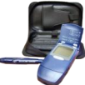 | If you have Diabetes, tell us about how you manage this and how well controlled it is. Tell us any concerns you have and tell us about any diabetes specialist who helps you. Have you been for diabetic eye screening? Have you had blood tests?
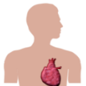 | Tell us about your heart. Have you noticed anything unusual? Is it beating really fast even when you are resting? Do you get dizzy? Do you have any family of history of heart disease?  Tell us if you have chest pain. What did it feel like and when does it happen?  Do you have swollen ankles or feet? When did this start?
  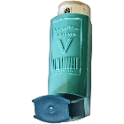 | Tell us about your breathing. Do you have any changes with your breathing e.g., short of breath more easily, wheezing, coughing, or long Covid symptoms?  If you have asthma, tell us whether this has been better or worse this year and how you manage it.
 | Tell us about any changes with your skin. Do you have any pressure sores, moisture lesions, dry skin, psoriasis, eczema? Has this got worse? How do you manage it? If you have moles, do you keep an eye on them for changes?
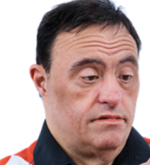 | Tell us about any changes you have noticed in behaviour e.g., memory loss, mood changes, poor sleep, confusion. Do you have any idea of what may have happened to cause these changes?
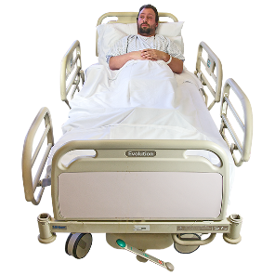 | Have you had any Hospital Admissions in the last Year? Was this an unplanned hospital admission? What were the reasons? Could this have been avoided if you had been able to spot signs of changes earlier?
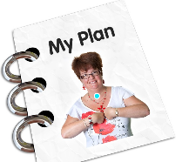 | Tell us if you have an end-of-life plan in place? (If you are supporting the person, this plan should be in place if the answer is NO to the question: ‘Would you be surprised if this person died in the next year?’)
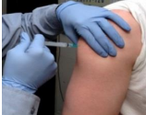 | Tell us about which vaccines you have had. Have you had any problems when trying to have a vaccine?  Have you had :  ALL the Coronavirus vaccinations?  Flu vaccination (in the last 12 months):  Pneumococcal vaccination:  Hepatitis B vaccination:  HPV vaccine: [This should have been given at school but if it wasn’t tell us because you can have it up to age 15 and it reduces the risk of cervical cancer]
Do you have any other questions about staying healthy that you want to talk about at your Annual Health Check?

What happens in the annual health check appointment?

The GP/Practice Nurse may:
- Check your feet and skin
- Check your blood pressure and pulse
- Listen to your chest and heart
- Check if you are a healthy weight by working out your BMI [body mass index]
- Feel your tummy
- Look in your ears, eyes and mouth
- Do a breast or testicle check or talk to you about this.
- Do any checks that are needed if you have a syndrome.
- Talk to you about having a blood test if it is needed to check your health.
- Review any medication to check if you still need it and it’s the right amount
- Give you a health action plan of things to do to stay healthy
Please tell us if you are worried about having any of these checks. It is better to say that you are worried as we may be able to help you to feel more relaxed about them. We really want you to feel safe and happy when you come for your appointment!

Thank you very much for completing this form. The annual health check is such an important way of ensuring that people with learning disabilities stay healthy.

Please use the Stay Healthy at Home Checklist as part of your health check action plan before your next Annual Health Check. It may be given to you by your GP at your appointment and it is available here www.hertfordshire.gov.uk/stayhealthyathome

