**Baldock Library Visual Story**

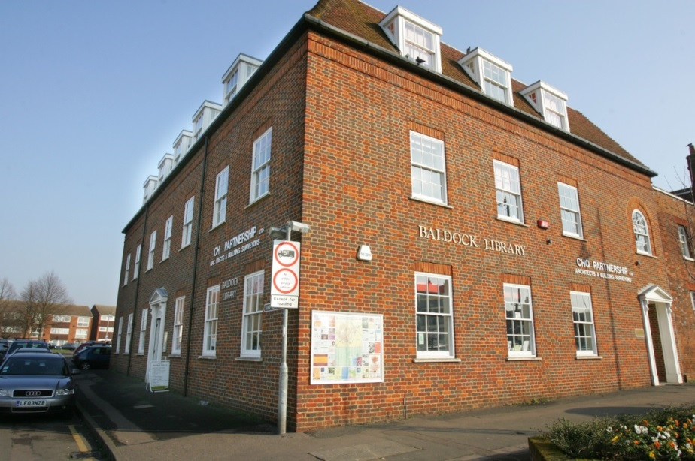

**Baldock Library, Simpson Drive, Baldock, SG7 6DH**

**Opening Hours:**

|  |  |  |  |
| --- | --- | --- | --- |
| Monday | 10.00am | - | 5.00pm |
| Tuesday | 10.00am | - | 5.00pm |
| Wednesday | 10.00am | - | 5.00pm |
| Thursday | 10.00am | - | 6.00pm |
| Friday | Closed |  |  |
| Saturday | 9.00am | - | •1.00pm |
| Sunday | Closed |  |  |

This is a simple guide to help people visiting Baldock Library for the first time, if you have any questions please ask the staff.

|  |  |
| --- | --- |
| a large brick building on a street corner | This is Baldock Library   |
| a member of staff is sitting behind a desk, looking at computer screen | This is the help desk please ask for help here.    You may have to wait if we are busy. |
| a woman looking straight at the camera showing her staff badge | Library staff are here to help. All library staff wear a badge like this.   |
| library cards, front and back | This is a library card, you will get one when you become a library member.    You need a library card to borrow books and DVDs and to use the computers.  To get a library card, ask the staff at the help desk. |
| **headphones** | Sometimes we have noisy times in the library and you may wish to visit at a quieter time.    Or you can bring some ear defenders to wear. |
| pink self service kiosk | This is a kiosk. You can borrow and return books here.    Follow the instructions on the screen. Ask the library staff if you need help.  If it is busy you may need to queue. |
| children's library with wooden boxes full of picture books, shelves on the wall full of books and a blue sofa | This is the children’s area.   |
| cid:9592df86-4086-4b37-86da-020fac688fe8@Hertfordshire.gov.uk | There are lots of books you can borrow.   |
| shelves showing magazines | There are magazines which you can borrow.   |
| metal shelving with books in the foreground with a desk and chairs in the background | This is the Teenage area just inside the door.   |
| large square table with 10 chairs around it | This is the quiet study area. There is free Wi-Fi in the library.   wifi logo  Ask staff for login details. |
| long desk against the wall with 4 computers and 4 chairs in front | These are some of our computers which you can use.    Library members can use them for free for one hour a day.  If the computers are busy you may need to book. Ask the library staff if you need help. |
| 2 small low tables with magazines and 3 tub chairs with library shelving in the background | This is an area to sit and read in.   |
| someone by the self service kiosk, pointing at the screen | When you are ready to leave the library, take the things that you want to borrow to the kiosk and follow the instructions on the screen.    Ask the library staff if you need help.  If it is busy you may need to queue. |
| someone by a self service kiosk holing a library card | You can take the things you have borrowed home. Print a receipt so you know when you need to bring them back to the library.    Remember to return or renew your items on time to avoid charges.  You can renew your items at the kiosk or:   * ask at the desk * online at [www.hertfordshire.gov.uk/libraries](http://www.hertfordshire.gov.uk/libraries) * Telephone: 0300 123 4049 * Textphone: 0300 123 4041 |
| person putting a book in a small bag | We hope you enjoyed the story.  If you need any extra help or information please ask a member of staff.     For more information on the library please visit our website:  [www.hertfordshire.gov.uk/baldocklibrary](https://www.hertfordshire.gov.uk/baldocklibrary)  Please come back soon. ☺ |