**Berkhamsted Library Visual Story**

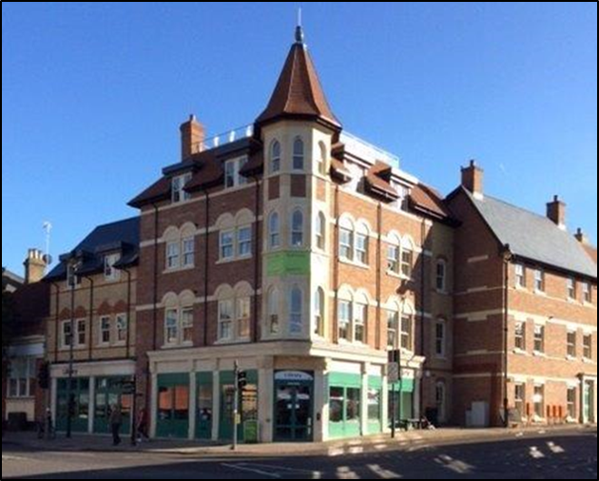

**Berkhamsted Library, 158 High Street, Berkhamsted, HP4 3HB**

This is a simple guide to help people visiting Berkhamsted Library for the first time, if you have any questions, please ask the staff.

**Opening Hours:**

**Staffed hours**:

|  |  |
| --- | --- |
| Monday | 9.30am - 5.30pm |
| Tuesday | 9.30am - 5.00pm |
| Wednesday | 9.30am - 5.00pm |
| Thursday | Closed |
| Friday | 9.30am - 5.00pm |
| Saturday | 9.30am - 4.00pm |
| Sunday | Closed |

You can also visit the library when it is quiet and there are no staff present during Open+ hours. You will need to fill in a form to obtain access at these times. Please ask staff.

**Open+ hours**:

|  |  |  |
| --- | --- | --- |
| Monday | 🕖7.00am - 9.30am | 5.30pm - 🕗8.00pm |
| Tuesday | 🕖7.00am - 9.30am |  |
| Wednesday | 🕖7.00am - 9.30am |  |
| Thursday | 🕖7.00am | 🕗8.00pm |
| Friday | 🕖7.00am - 9.30am | 5.00pm - 🕗8.00pm |
| Saturday | 🕖7.00am - 9.30am |  |
| Sunday | Closed | Closed |

|  |  |
| --- | --- |
| **outside view of a large building on a street corner** | This is Berkhamsted Library   |
| a lady is standing behind computer desks | This is the help desk.    Ask here if you need help or have any questions.  If it is busy you may need to queue. |

|  |  |
| --- | --- |
| a lady with a staff badge is standing between bookshelves | Library staff are here to help.  All library staff wear a badge like this.   |
| **headphones** | Sometimes we have noisy times in the library and you may wish to visit at a quieter time.    Or you can bring with you some ear defenders to wear. |

|  |  |
| --- | --- |
| **library cards front and back** | This is a library card, you will get one when you become a library member.    You need a library card to borrow books and to use the computers.  To get a library card, ask the staff at the help desk. |
| a self service machine for borrowing and returning books | This is a kiosk. You can borrow and return books here.    Follow the instructions on the screen. Ask the library staff if you need help.  If it is busy you may need to queue. |
| inside a library with bookshelves either side and a table in the back of the room | This is the children’s area.   |
| **library bookshelves** | There are lots of books you can borrow.    If you cannot find a book you are looking for, you can ask the library staff to help. |
| magazines displayed on a shelf | You can also borrow magazines.   |
| bookshelves with audiobooks on CD | You can also listen to books on CD.   |
| toilet sign with stylised pictures of a woman, a man, a person changing a baby and a person in a wheelchair | There is a toilet in the library.    It has an alarm on a cord and a baby change facility. The light is turned on by movement not by a switch.  If it is busy you may need to queue. |
| desk with computers | These are the computers. Library members can use them for free for two hours a day.    If the computers are busy you may need to book.  Ask the library staff if you need help. |
| desk with partition for individual study spaces | This is the study area. There is free Wi-Fi in the library. wi-fi logo    Ask staff for login details.  Desks with power sockets are available.  You can charge your own device here. |
| cid:e43681d1-e20f-4615-8f86-7795d43b3938@Hertfordshire.gov.uk | When you are ready to leave the library, take the things that you want to borrow to the kiosk and follow the instructions on the screen. Ask the library staff if you need help.  If it is busy you may need to queue.   |

|  |  |
| --- | --- |
| cid:4c311b1f-8343-42b0-8ecf-9e181c4cca5d@Hertfordshire.gov.uk | You can take the things you have borrowed home. Print a receipt so you know when you need to bring them back to the library.    Remember to return or renew your items on time to avoid charges.  You can renew your items at the kiosk or:   * ask at the desk * online at [www.hertfordshire.gov.uk/libraries](http://www.hertfordshire.gov.uk/libraries) * Telephone: 0300 123 4049 * Textphone: 0300 123 4041 |
| cid:38b11f0d-3e1d-4975-99eb-d73f8a421c04@Hertfordshire.gov.uk | We hope you enjoyed the story.  If you need any extra help or information please ask a member of staff.     For more information on the library please visit our website:  [www.hertfordshire.gov.uk/berkhamstedlibrary](http://www.hertfordshire.gov.uk/berkhamstedlibrary)  Please come back soon. ☺ |