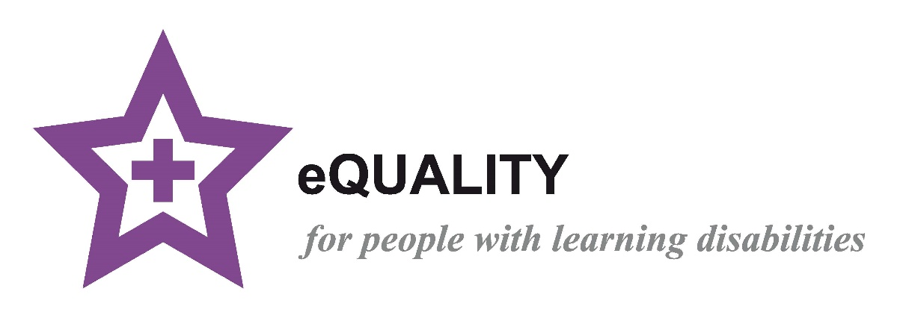

**The Purple Star Strategy Training**

**Handbook**

**H**

**Produced by the Health Liaison Team,**

**Hertfordshire Adult Disability Service**

Improving health outcomes for people with learning disabilities

|  |  |
| --- | --- |
| **PAGE** | **INDEX** |
| **1** | Front cover |
| **2** | Index |
| **4** | Video links |
| **5** | Hertfordshire Services |
| **7** | The Purple Star Strategy |
| **8** | Learning disability awareness |
| **9** | Training record |
| **10** | Pledges in practice |
| **11** | **Criteria 1 – Learning Disability Register** |
| **12** | Definition of learning disability |
| **13** | A mild and moderate learning disability |
| **14** | A severe learning disability |
| **15** | Don’t assume |
| **16** | What causes a learning disability/Causes of learning disabilities |
| **17** | **Talk and make a pledge – criteria 1 ( part 1)** |
| **18** | Importance of adding someone to the LD register and coding |
| **19** | Inclusion Tool |
| **21** | Learning disability read codes |
| **22** | **Talk and make a pledge – Criteria 1 ( part 2 )** |
| **23** | **Criteria 2 – Learning Disability Champion** |
| **24** | Barriers to healthcare |
| **26** | Additional health conditions |
| **27** | **Talk and make a pledge – Criteria 2 (part 1)** |
| **28** | Meet Simon |
| **29** | **Talk and make a pledge – Criteria 2 (part 2)** |
| **30** | **Criteria 3 – Reasonable Adjustments** |
| **31** | TEACH |
| **33** | Tips for communication |
| **35** | Harry Potter reasonable adjustment/**Talk and make a pledge Criteria 3** |
| **36** | **Criteria 4 – The Purple Folder** |
| **37** | Purple folder information |
| **40** | Purple card and health Apps |
| **41** | **Talk and make a pledge – Criteria 4** |
| **42** | **Criteria 5 Accessible Environment** |
| **43** | Sensory overload |
| **45** | Accessible environment/**Talk and make a pledge – Criteria** **5** |
| **46** | **Criteria 6 – Annual health checks and tools** |
| **47** | Annual health checks |
| **48** | **Minimum standard** |
| **51** | **Annual health check resources and health guides** |
| **53** | Preparing for a healthy adulthood |
| **54** | **Talk about and make a pledge – Criteria 6** |
| **55** | **Criteria 7 – Flu and Covid vaccines** |
| **56** | Flu vaccine |
| **57** | Covid vaccine/ **Talk and make a pledge – Criteria** **7** |
| **58** | **Criteria 8 – Accessible Information Standards** |
| **59** | Accessible information |
| **61** | **Talk and make a pledge – Criteria 8** |
| **62** | **Criteria 9 – Safeguarding** |
| **63** | Safeguarding |
| **64** | The murder of Steven Hoskin |
| **65** | The murder of Steven Hoskin/ **Talk and make a pledge – Criteria 9** |
| **66** | **Criteria 10 – Mental Capacity Act and Best Interest decisions** |
| **67** | Mental capacity Act and Best interest decisions |
| **68** | Principles of MCA |
| **70** | **Talk about and make a pledge – Criteria 10** |
| **71** | **Criteria 11 – LeDeR and DNA CPR** |
| **72** | LeDeR |
| **73** | DNACPR/ReSPECT |
| **76** | **Talk about and make a pledge – Criteria 11** |
| **77** | **Criteria 12 – Health Equality Targets** |
| **78** | STOMP |
| **79** | Meet Trevor |
| **80** | STOMP process |
| **81** | Cancer Screening |
| **82** | Meet Sarah & Other screenings |
| **84** | **Talk and make a pledge – Criteria 12** |
| **85** | **Criteria 13 – Training** |
| **86** | Video links |
| **88** | **Talk about and make a pledge Criteria 13** |
| **89** | **Criteria 14 – Link nurse** |
| **90** | Healthcare support pathway |
| **91** | Nursing service outline and referrals, Referral form/ **Talk about and make a pledge – Criteria 14** |
| **92** | **Criteria 15 – Feedback** |
| **93** | Feedback/ **Talk about and make a pledge Criteria 15** |
| **94** | Purple All Star’s |
| **95** | Purple All Star’s – videos and links |
| **96** | Safe in the sun and other video links |
| **97** | Useful websites and contact numbers |

|  |  |
| --- | --- |
| **VIDEO LINKS – can all be found here: *Please subscribe to our channel***  [**community learning disability nursing service - YouTube**](https://www.youtube.com/channel/UCI_FEr3X73M---A_bpnxUnQ/videos) | |
| * [Definitions - The Difference between Learning Disability, Learning Difficulty and Autism](https://www.youtube.com/watch?v=UZNKRzQ6ae4&t=127s) * [Communication Barriers](https://www.youtube.com/watch?v=dQBmOsz9kCQ&t=2s) * [Your communication](https://www.youtube.com/watch?v=ioXQjktOe8o) * [Reasonable Adjustments – TIME](https://www.youtube.com/watch?v=_eIB8V-PF2A) * [Reasonable Adjustments – ENVIRONMENT](https://www.youtube.com/watch?v=6Cl2lqOhWEc) * [Reasonable Adjustments – ATTITUDE](https://www.youtube.com/watch?v=ad1oM4QcnoI) * [Reasonable Adjustments – COMMUNICATION](https://www.youtube.com/watch?v=_e3zefo4KzM) * [Reasonable Adjustments – HELP](https://www.youtube.com/watch?v=HqxtKVJX18I&t=131s) * [Capacity and Best Interest](https://www.youtube.com/watch?v=Mw40MeC9e6g) * [Helping people be more self-aware of their health](https://www.youtube.com/watch?v=2pJsjJe6tXE) * [Early spotting of possible safeguarding concerns](https://www.youtube.com/watch?v=UxWxNLKCe3Q) | |
| * [Bristol stool chart explained](https://www.youtube.com/watch?v=9Wv87x9ho9s) * [Bowel Health](http://www.hertfordshire.gov.uk/LDHEALTHPROFBowelhealth) * [What is Autism](https://www.nhs.uk/conditions/autism/what-is-autism/) | |
| * [Purple Folder Video](https://www.youtube.com/watch?v=ur7VQ6YqFaM) * [Me on my best day](https://www.youtube.com/watch?v=oA-RP4JPmz8) * [Be your own leader](https://youtu.be/HmJB3I9h3sc) * [Through our eyes](https://youtu.be/0_zOx88ZGZ0) * [TEACH rap](https://www.youtube.com/watch?v=eOIrV27P88Q) * [The handwashing rap](https://www.youtube.com/watch?v=4eY59qr2FTo) * [Check it out](https://www.youtube.com/watch?v=beQHs9x-aiQ) | |
| * [Annual Health Check Preparation Form](https://www.hertfordshire.gov.uk/media-library/documents/adult-social-services/learning-difficulties-and-dementia/professionals/annual-health-check-preparation-form-v5-april-24.docx) * [Stay Healthy At Home Checklist](http://www.hertfordshire.gov.uk/stayhealthyathome) * [How to do a good annual health check](https://www.youtube.com/watch?v=lEEpias8OVA) * [Breast Checking Guide](https://www.hertfordshire.gov.uk/media-library/documents/adult-social-services/factsheets/easy-read/breast-checking-info-pack.pdf) * [Cervical Screening Guide](https://www.hertfordshire.gov.uk/media-library/documents/adult-social-services/factsheets/easy-read/cervical-screening-guide.pdf) * [Breast Screening Booklet](https://www.hertfordshire.gov.uk/media-library/documents/adult-social-services/factsheets/easy-read/breast-screening-information-pack.pdf) * [Checking Your Testicles for Lumps Guide](https://www.hertfordshire.gov.uk/media-library/documents/adult-social-services/factsheets/easy-read/complete-testicle-information-pack.pdf) * [Abdominal Aortic Aneurysm (AAA) Screening](https://www.hertfordshire.gov.uk/media-library/documents/adult-social-services/factsheets/easy-read/abdominal-aortic-aneurysm-aaa-screening-easy-read-factsheet.pdf) * [know your poo guide](https://www.youtube.com/watch?v=9Wv87x9ho9s) * [know your wee guide](https://www.hertfordshire.gov.uk/media-library/documents/adult-social-services/learning-difficulties-and-dementia/urine-colour-chart-updated.pdf) * [the sexual health and relationships video](https://www.youtube.com/watch?v=14yKxLZP_0M&t=2s) * [Carer's Guide: Tackle Obesity](https://www.hertfordshire.gov.uk/media-library/documents/adult-social-services/factsheets/easy-read/weight-carers-guide-tackling-obesity.pdf) * [Easy read: Obesity health risks guide](https://eur02.safelinks.protection.outlook.com/?url=https%3A%2F%2Fwww.hertfordshire.gov.uk%2Fmedia-library%2Fdocuments%2Fadult-social-services%2Ffactsheets%2Feasy-read%2Fobesity-easyread-health-risks-v1.pdf&data=05%7C02%7CEdi.Curran%40hertfordshire.gov.uk%7Cef04b2e3109f4c20a88a08dc62de9f1b%7C53e92c3666174e71a989dd739ad32a4d%7C0%7C0%7C638493955529566013%7CUnknown%7CTWFpbGZsb3d8eyJWIjoiMC4wLjAwMDAiLCJQIjoiV2luMzIiLCJBTiI6Ik1haWwiLCJXVCI6Mn0%3D%7C0%7C%7C%7C&sdata=cyU2OpfejvZ19n%2B9WdJQFZSjt%2FfGj%2BX%2BxyHDd%2Brn%2ByI%3D&reserved=0) * [here is some information about those health problems](https://eur02.safelinks.protection.outlook.com/?url=https%3A%2F%2Fwww.hertfordshire.gov.uk%2Fmedia-library%2Fdocuments%2Fadult-social-services%2Ffactsheets%2Feasy-read%2Fobesity-easyread-health-risks-v1.pdf&data=05%7C02%7CEdi.Curran%40hertfordshire.gov.uk%7Cef04b2e3109f4c20a88a08dc62de9f1b%7C53e92c3666174e71a989dd739ad32a4d%7C0%7C0%7C638493955529577648%7CUnknown%7CTWFpbGZsb3d8eyJWIjoiMC4wLjAwMDAiLCJQIjoiV2luMzIiLCJBTiI6Ik1haWwiLCJXVCI6Mn0%3D%7C0%7C%7C%7C&sdata=qZILxjmSXZm1yk8fdTWJCtDk%2FlOQ83bs8zhsukWMexc%3D&reserved=0) * [Here is a recording chart to keep a check on your weight and see if you are a healthy weight.](https://eur02.safelinks.protection.outlook.com/?url=https%3A%2F%2Fwww.hertfordshire.gov.uk%2Fmedia-library%2Fdocuments%2Fadult-social-services%2Ffactsheets%2Feasy-read%2Fweight-chart-with-bmi.pdf&data=05%7C02%7CEdi.Curran%40hertfordshire.gov.uk%7Cef04b2e3109f4c20a88a08dc62de9f1b%7C53e92c3666174e71a989dd739ad32a4d%7C0%7C0%7C638493955529584892%7CUnknown%7CTWFpbGZsb3d8eyJWIjoiMC4wLjAwMDAiLCJQIjoiV2luMzIiLCJBTiI6Ik1haWwiLCJXVCI6Mn0%3D%7C0%7C%7C%7C&sdata=7Bu3873Ldpr3B95uzyTx3ExkI3s9C4xDz73BoQBnYu4%3D&reserved=0) * [Here is some information for carers about how to weigh people who are in wheelchairs](https://www.hertfordshire.gov.uk/media-library/documents/adult-social-services/factsheets/easy-read/wheelchair-scale-guidance.pdf) * [Here is link to an NHS site which tells you whether you are a healthy weight](https://eur02.safelinks.protection.outlook.com/?url=https%3A%2F%2Fwww.nhs.uk%2Flive-well%2Fhealthy-weight%2Fbmi-calculator%2F&data=05%7C02%7CEdi.Curran%40hertfordshire.gov.uk%7Cef04b2e3109f4c20a88a08dc62de9f1b%7C53e92c3666174e71a989dd739ad32a4d%7C0%7C0%7C638493955529599098%7CUnknown%7CTWFpbGZsb3d8eyJWIjoiMC4wLjAwMDAiLCJQIjoiV2luMzIiLCJBTiI6Ik1haWwiLCJXVCI6Mn0%3D%7C0%7C%7C%7C&sdata=oczbNU422RSsAmucB1ffs%2FfGwytdt21c4nLoOp%2FIGeg%3D&reserved=0) * [keeping your mouth healthy guide](https://www.hertfordshire.gov.uk/media-library/documents/adult-social-services/learning-difficulties-and-dementia/dental-care-easyread-20.6.19.pdf) * [Preparing for healthy adulthood - chapter 1](https://youtu.be/8qtcKDHK10M) * [Preparing for healthy adulthood - chapter 2](https://youtu.be/1K6YKHk_rYA) * [Preparing for healthy adulthood - chapter 3](https://youtu.be/obFOuL33jCc) * [Preparing for healthy adulthood - chapter 4](https://youtu.be/Lm1PnEHKObI) * [Preparing for healthy adulthood - chapter 5](https://youtu.be/rmKDwXG44YY) * [Preparing for healthy adulthood - chapter 6](https://youtu.be/x5LHrU-_nAw) | |
| * [Gavin says 'Get your Covid-19 vaccination'](https://www.youtube.com/watch?v=3HRKQ-8eAIE) | |
| * [Safeguarding](https://www.youtube.com/watch?v=UxWxNLKCe3Q&t=22s) * [Reasonable Adjustments](https://www.youtube.com/watch?v=gUHHoZZcUTo&feature=emb_title) | |

**Hertfordshire Services**

**Purple Star Strategy Team 01438 844 681**

[**purplestarstrategy@hertfordshire.gov.uk**](mailto:purplestarstrategy@hertfordshire.gov.uk)

If you have any queries throughout your Purple Star Accreditation or Monitoring Process, please don’t hesitate to get in touch with the team on the above number or email address.

**Health Professionals can find information on our service and tools at -** [**www.hertfordshire.gov.uk/LDprofessionals**](http://www.hertfordshire.gov.uk/LDprofessionals)

**People with learning disabilities and their carers can also find information about our services and keeping healthy at –**

[**www.hertfordshire.gov.uk/LDMyHealth**](http://www.hertfordshire.gov.uk/LDMyHealth)

**Health Liaison Team 01438 845 372**

[**healthliaisonteam.referrals@hertfordshire.gov.uk**](mailto:healthliaisonteam.referrals@hertfordshire.gov.uk)

The nurses in this team support people with a learning disability in accessing secondary health care. If you refer someone to secondary health and have concerns about how their health needs will be met, then contact this team. Leave a message and they will call back. This service is available Monday-Friday 9am-5pm.

**Purple Folder 01438 843 848**

[**edi.curran@hertfordshire.gov.uk**](mailto:edi.curran@hertfordshire.gov.uk) **or** [**purplestarstrategy@hertfordshire.gov.uk**](mailto:purplestarstrategy@hertfordshire.gov.uk)

If a person with a learning disability doesn’t have a purple folder and would like one, this number can also be called if a person would like replacement pages. Replacement pages are also available on our website to download and print [here](https://www.hertfordshire.gov.uk/media-library/documents/adult-social-services/learning-disability-partnership-board/my-purple-folder-december-2017.pdf) or go to purple folder section at [**www.hertfordshire.gov.uk/LDmyhealth**](http://www.hertfordshire.gov.uk/LDmyhealth)

**GP Link Nurses**

Every GP surgery has a Community Learning Disability Link Nurse from your local community learning disability team. You can contact them for non-urgent discussions via their team email address and marked for the attention of the Link Nurse for your practice:

[watfordthreerivers.adt@hertfordshire.gov.uk](mailto:watfordthreerivers.adt@hertfordshire.gov.uk) 01442 454 343

[stalbans.adt@hertfordshire.gov.uk](mailto:stalbans.adt@hertfordshire.gov.uk) 01438 843 166

[dacorum.adt@hertfordshire.gov.uk](mailto:dacorum.adt@hertfordshire.gov.uk) 01442 454 444

[hertsmere.adt@hertfordshire.gov.uk](mailto:hertsmere.adt@hertfordshire.gov.uk) 01442 454 242

[welwynhatfield.adt@hertfordshire.gov.uk](mailto:welwynhatfield.adt@hertfordshire.gov.uk) 01438 843 600

[northherts.adt@hertfordshire.gov.uk](mailto:northherts.adt@hertfordshire.gov.uk) 01438 845 629

[Stevenage.adt@hertfordshire.gov.uk](mailto:Stevenage.adt@hertfordshire.gov.uk) 01438 845 529

[eastherts.adt@hertfordshire.gov.uk](mailto:eastherts.adt@hertfordshire.gov.uk) 01438 843 111

[Broxbourne.adt@hertfordshire.gov.uk](mailto:Broxbourne.adt@hertfordshire.gov.uk) 01438 843 400

[0-25_Central@hertfordshire.gov.uk](mailto:0-25_Central@hertfordshire.gov.uk) 01438 845 258

To make a referral to the Adult care nursing service – you need to complete the nursing referral form [referral form](https://www.hertfordshire.gov.uk/media-library/documents/adult-social-services/ld-gp-referral-form.pdf) and it can be returned direct to the relevant team [above]

**Health and Social Care Service - 0300 123 4042**

**Monday - Friday 9-5 service**

If you feel someone may need some help from a Community Learning Disability Nurse or Social Worker.

This may be due to concerns you have about:

* Family circumstances
* Care Support
* Low level mental health anxiety concerns
* Meeting / managing their health needs
* Or anything else – this is your starting point

**Single Point of Access (HPFT) 0300 777 0707**

If someone presents with significant mental health issues, then the best starting point is SPA as they can offer intensive support for people with a mental health and learning disability diagnosis

**beyond a 9-5 Monday-Friday service.**

**Herts Help 0300 123 4044**

[HertsHelp - We're here for you](https://www.hertshelp.net/hertshelp.aspx)[info@hertshelp.net](mailto:info@hertshelp.net)This is the generic Hertfordshire help service to support people in finding the right service they need. They know what’s available, including from private and voluntary sector in all aspects of life.

**LEDER**

To tell LeDeR about the death of someone with a learning disability: **01278 727411**

[Report the death of someone with a learning disability (leder.nhs.uk)](https://leder.nhs.uk/report) <https://leder.nhs.uk/report>

# The Purple Star Strategy

The Purple Star brand was developed in 2014 by the Hertfordshire Community Learning Disability Services through the Health Liaison Team [Herts County Council] in partnership with people with a learning disability, people who support them and the University of Hertfordshire Business School.

The Purple Star is a Trademark which is accredited to Primary health services who demonstrate the delivery of high quality reasonably adjusted services to adults with learning disabilities across Hertfordshire, in line with the requirements of the Equality Act 2010.

Like a "kite mark" the presence of a Purple Star at a health service provider indicates that a defined set of standards, as set out in the Purple Star Promise, have been achieved by that health service provider and are consistently being maintained.

People with a learning Disability die an average of around 26 years younger than the rest of the population (LeDeR 2019) – the whole GP practice Team need to demonstrate they are working together to reduce the causes of this. There are 15 criteria for accreditation. This handbook and the video links will help all staff in the practice be able to identify the part that they can play that will make a difference.

### The National Mandatory Learning Disability and Autism Training Provides you with the foundation of understanding – The Purple Star accreditation aims to help you to embed this in your services practice.

◊

**Learning Disability Awareness**

**Purple Star Strategy Training Record**

**Name of Service:**

|  |  |  |  |
| --- | --- | --- | --- |
| **Date** | **Name of staff** | **Position** | **Trained by** |
|  |  |  |  |
|  |  |  |  |
|  |  |  |  |
|  |  |  |  |
|  |  |  |  |
|  |  |  |  |
|  |  |  |  |
|  |  |  |  |
|  |  |  |  |
|  |  |  |  |
|  |  |  |  |

The following pages have been provided by the Purple Star Team to be used by the learning disability champion as an in-house training resource. We recommend new staff, staff who have been unable to attend formal training, or staff who would like a refresher to read through these pages. The learning disability champion may also like to use these, and the videos embedded in bitesize chunks as refresher sessions within practice meetings. The Purple Star Team are also available to provide formal training as and when required by the service. Please keep a log of any in-house training below:

**Pledges in Practice**

After each section of Training Below there are ‘Talk about and Make a Pledge’ suggestions. Please use this page to log individuals or groups of staff’s pledges for adapting practice following the completion of each section.

|  |  |  |  |  |
| --- | --- | --- | --- | --- |
| **Date** | **Training criteria (1-15)** | **Name(s) of staff making the pledge** | **Role(s) within Practice** | **What is your pledge?** |
|  |  |  |  |  |
|  |  |  |  |  |
|  |  |  |  |  |
|  |  |  |  |  |
|  |  |  |  |  |
|  |  |  |  |  |
|  |  |  |  |  |
|  |  |  |  |  |

CRITERIA 1

**Identify people who may have a learning disability who are not yet read-coded onto your LD register**

* Do All Staff Understand What a Learning Disability is?
* Do they know about checking someone has the correct read code?
* Do they know about the **Inclusion Tool** and how to use this to ascertain if someone is eligible to be on the Learning Disability QoF register?
* Do they know WHY this is important and the impact this can have?
* Do they know what part they can play?

**Definitions**

You need to be able to identify the Patients on your register to make sure they get the help they need to receive the appropriate health care from your practice.

Here is a refresher on the definition of a Learning Disability and some core examples to help embed the understanding.

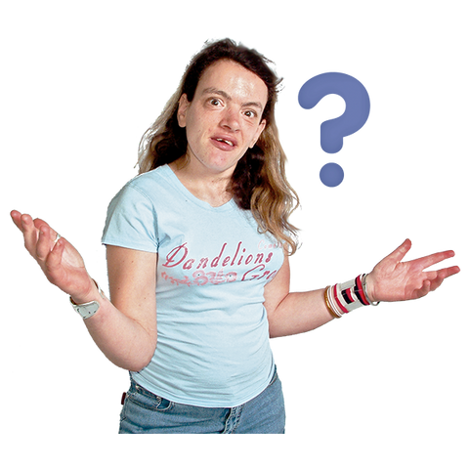**The definition of a Learning Disability is:**

* **Impaired Intelligence (IQ below 70)** but IQ is rarely tested
* **Reduced ability to understand new or complex information** and impaired ability to learn new skills
* **Impaired Social Functioning**
* **Reduced ability to cope independently**
* **Started in childhood** Before the age of 18
* **Life long**
* **With lasting effect** on development

A learning disability is a reduced intellectual ability and difficulty with everyday activities. For example, household tasks, socialising or managing money – which affects someone for their whole life.

Learning **disability** is often confused with learning **difficulty**. Dyslexia and Dyspraxia are called a “learning difficulty” **NOT** a learning disability because they do not affect a person’s intellect or ability to learn, it just makes it more difficult.

Mental health problems can also present as a learning disability but again, a mental health problem does not affect intellect or the ability to learn but may affect the person’s ability to absorb information at that time.

**Autism is not a learning disability.** The person may have full intellectual ability but struggle with understanding societies typical communication cues and styles. Some Autistic people do have an underlying learning disability as well.

Please now watch this short video about what a learning disability is.

[1. LD awareness for health professionals - definitions](https://www.youtube.com/watch?v=UZNKRzQ6ae4&t=1s) This is a snippet taken from a training session to help health professionals understand The Difference between Learning Disability, Learning Difficulty and Autism.

You can also watch the Video on Autism, as this patient group equally need support to overcome health inequalities <https://www.nhs.uk/conditions/autism/what-is-autism/>



**Classification of Learning Disability in Primary Care**

**Mild learning disability**

* **Social functioning** – ability to maintain social network independently
* **Education** – likely to have been educated in mainstream school with recognised additional needs
* **Dependency** – able to live independently with recognised need for support
* **Communication** – likely to be verbally communicative
* **Understanding** – may appear to have more understanding than they do, likely to have difficulty processing new or complex information unless clearly and fully explained in an understandable way

**Example: ‘Geoff’**

Geoff is 31 years old and lives in his own flat with his girlfriend. He has a part time job at B&Q and is a season ticket holder at the local football club. Geoff is quite chatty and often gives the impression of understanding when he doesn’t. Geoff needs support understanding letters and finances. He went to the local comprehensive school and had some support with reading and writing. He left school with no formal qualifications.

**Moderate learning disability**

* **Social functioning** – likely to need support to maintain social networking
* **Education** – likely to have been educated in specialist or mainstream education with dedicated support
* **Dependency** – likely to need support with daily living
* **Communication** – may or may not have verbal communication therefore reliable communication would need to be facilitated by others who know them well. Likely to benefit from supplementary communication tools such as easy read information, Makaton etc
* **Understanding** – limited understanding beyond clear and straight forward conversation Likely to have difficulty processing new or complex information

**Example: ‘Charlotte’**

Charlotte is 25 years old and has Down’s syndrome. She received her primary education in a mainstream school with individual support and transferred to a special school for her secondary education. She lives at home with her parents but has aspirations of having her own flat. Charlotte attends college three days a week and a local weekly disco for people with learning disabilities, where she meets her boyfriend. Charlotte can be familiar and very tactile with people she does not know well making her extremely vulnerable. She has a few well-rehearsed sentences that give an impression of a higher level of communication than is the case.

**Severe learning disability**

**(Including those with profound and multiple learning disability)**

* **Social functioning** – likely to be dependent on others to have any social network
* **Education** – likely to have been educated in specialist education
* **Dependency** –dependent on others for daily living. They may or may not have a physical disability
* **Communication** – individualised communication and use of non-verbal techniques including body language and behaviour. Communication is likely be very difficult so consultation with others who know them well is important
* **Understanding** – very limited or no obvious understanding, with difficulty processing basic information

**Example: ‘Jenny’**

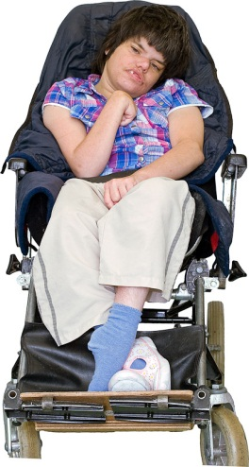

Jenny is16 years old and has both a severe learning disability and some physical disability which means she is unable to walk unaided. She is totally reliant on others to meet her personal care needs. She attends the local special school and will leave when she is 19 years old. She lives with her mother and two younger siblings. Her social network is through school and short break service. Jenny has no verbal communication and responds best to familiar people. Jenny is more likely to respond to a simple single choice question as she finds it difficult to communicate complex choices or information. When Jenny is in pain or distressed, she usually bites her hands, rocks back and forth and cries.

**Don’t Assume!**

Don’t assume, based on appearance or behaviour,

that someone does or does not have a learning disability!



Rosie Jones – comedian

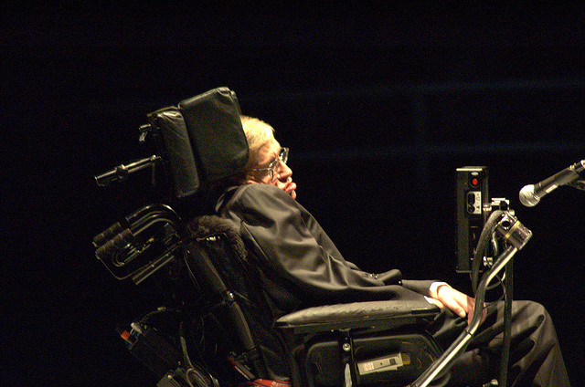Stephen Hawking – Physicist, cosmologist and author

**What causes a learning disability?**

*A learning Disability can be caused by:*

* **An inherited condition** – a condition passed down through the parents
* **Chromosomal differences**– Most syndromes can be identified through DNA analysis of chromosomal differences, for example, Downs Syndrome is caused by an additional part on Chromosome 21
* **Complications during birth** – reduced oxygen supply during birth can cause brain damage
* **A very premature birth** – the baby may not develop fully
* **Mother’s illness during pregnancy –** e.g.,Chicken pox in early pregnancy when the foetus may form a pox impacting brain development
* **The mother drinking during pregnancy** – this is called fetal alcohol syndrome
* **A debilitating illness or injury in early childhood** – e.g., a head injury from a car accident, bad fall, or Meningitis
* **Neglect and/or a lack of mental stimulation early in life** – if the brain isn’t given the chance to develop or the baby isn’t fed properly it can cause brain damage

**Some syndromes and conditions have very specific health concerns associated with them.**

For example, people with Downs Syndrome have higher risks of issues with eyesight and hearing, heart disease, dysphagia, GOARD, sleep apnea, mental health problems (25-30% suffer with anxiety and depression), early onset dementia (10-22% get it in their 40s), early menopause, osteoporosis, hypothyroidism (15-37%), diabetes type 1 and type 2, obesity (89-95%), skin conditions and cervical spine issues with degenerative changes (70%).

So as a medical professional it is always important to ascertain (and is a requirement as part of the annual health check) if they have syndrome specific additional potential comorbidities (this is the presence of two or more diseases or medical conditions in a patient).

**Talk and Make a Pledge - Criteria 1 (part 1)**

Was there anything on this section that you didn’t know?

What is your previous experience of people with learning disabilities?

Did you know the difference between learning disability and difficulty?

Make a pledge as to how you will use this information to adapt YOUR practice?

**QoF Coding**

**If you have identified someone who is not read coded as having a Learning Disability that you feel MAY meet the criteria, then it is important that this person is highlighted within the practice, so action can be taken.**

**Without that read code they will:**

* **NOT** be on the Learning Disability QoF register
* They will **NOT** receive the enhanced Health Services designed to bridge the health inequality gap
* This means that they will **NOT** be invited for an Annual Health Check
* They will **NOT** have the free Flu vaccine - respiratory illness is one of the leading causes of death in people with a learning disability
* They may **NOT** have reasonable adjustments offered to them that they need to be able to accept health treatment
* They will **NOT** be offered a Purple Folder
* They will **NOT** be supported to have the checks for STOMP
* They will **NOT** be supported by learning disability nurses to overcome barriers for the Cancer Screenings
* They will **NOT** be given additional support with barriers to COVID-19 vaccination by learning disability nursing
* They may **NOT** have their accessible information needs flagged on your system

**If you are unsure about any of these things – they will be covered as we go through this training.**

**Everyone in the practice can play their part in finding those unidentified patients who may need the enhanced learning disability service.**

**Here is the inclusion tool nationally recognised for GP surgeries to use.**

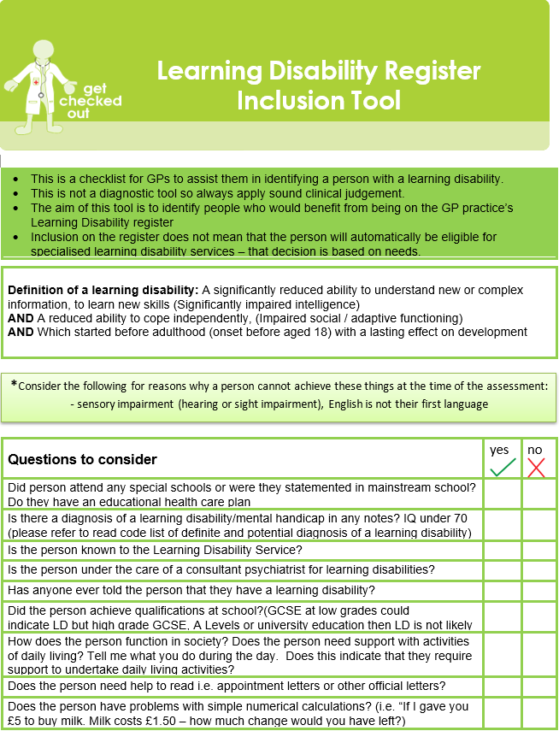

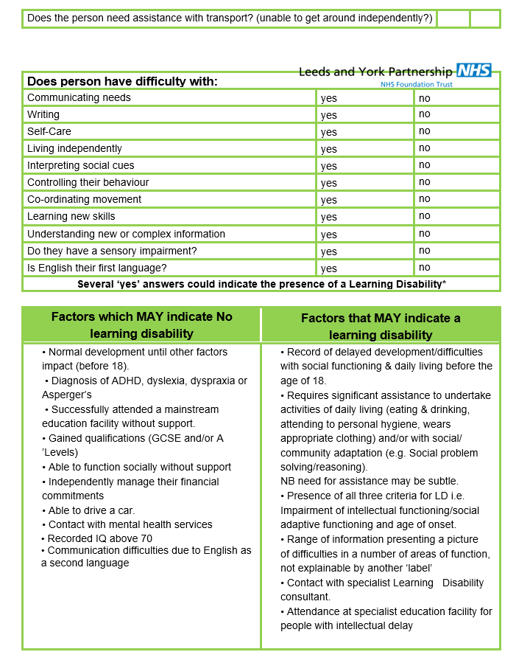

Here are some of the main Codes to be used – there is a full list on the website [www.hertfordshire.gov.uk/ldprofessionals](http://www.hertfordshire.gov.uk/ldprofessionals)

|  |  |  |  |
| --- | --- | --- | --- |
| **Learning Disability Read Codes** | | | |
| **The list is intended to be used in General Practice to identify those patients with a learning disability who will need to be included on GP learning disability registers and offered an annual health check (14 years of age or over).** | | | |
| **1. Administrative Codes**  Once patients with a learning disability have been identified they must be allocated administrative codes to ensure that they are included on the learning disability register and that their annual health check and health action plan status has been recorded.   The administrative codes for inclusion on the Learning Disability (QOF) register are shown below along with codes for recording annual health check status and ensuring payment under the DES. | | | |
|  | **Version 2 (5 byte)** | **Version 3** | **SNOMED Code** |
| On learning disability register | 918e. | XaKYb | 416075005 |
| Learning disability health examination* | 69DB. | XaPx2 | - |
| Learning disabilities annual health assessment* | 9HB5 | XaL3Q | 199751000000100 |
| Examination of a learning-disabled patient* | - | - | 442127005 |
| Learning disabilities health action plan completed | 9HB4. | XaJsd | 712491005 |
| Learning disabilities annual health assessment declined | 9HB6. | XaQnv | 514021000000103 |
| Learning disabilities health action plan reviewed | 9HB2. | XaJWA | 413163007 |
| Learning disabilities health action plan declined | 9HB0. | XaJW9 | 413162002 |
| * Either code will count towards achievement of Enhanced Service | |  |  |

**Talk and Make a Pledge – Criteria 1 (part 2)**

Within the practice do you know who is the LD champion to notify if you think a patient needs consideration for adding to the LD register?

Do they, or does someone else within your practice have the role of completing inclusion tools when someone is identified? (We can support the development of this if not)

What can you, in your role, do to help identify more people that may be missing out on the enhanced service they need?

CRITERIA 2

**How being a learning disability champion can make a difference and reduce health inequalities.**

* Why do you need an LD champion for admin as well as clinical?
* Why is the delivery of health care to your patients with a learning disability a team approach?
* What is the Enhanced health service for people with Learning Disabilities and how can the Learning Disability Champions (Admin and Clinical) support this?
* Why do people with a learning disability need an enhanced service and what difference can this enhanced service make?

**People with Learning Disabilities are dying considerably younger than the general population.**

Recap of Mandatory training with additional examples to help you reflect on the impact of your practices.

**Learning Disability Mortality Review (LeDeR) (2019)** found that people with Learning Disabilities are dying on average **26 years *younger*** than the general population. 23 years for men, and 29 years for women.

**The Confidential Inquiry into Premature Deaths of People with Learning Disabilities (CIPOLD) (2013)**. The inquiry looked at the deaths of 247 People with Learning Disabilities. The findings showed that nearly **50% of deaths were *avoidable*** compared to 24% in the rest of the population.

**What are the barriers to getting the same health outcomes as any other patient would get?**

**Communication** – if you are unable to tell someone you are in pain you might display behaviour that is misunderstood with nobody realising it relates to a health issue. This can lead to a delay in diagnosis that could be the difference between living and dying avoidably.

**Health Screening** – there is a low attendance rate for health screening among the learning disability population. This may be due to not understanding the importance of going, or family and carers not seeing it as critical, so avoiding it as it would be too challenging. Limited ability to weigh up the risk of not attending versus the dislike of going through the screening, means people may not get screened without understanding the risks this involves (**Mental Capacity**).

**Accessibility** – access to buildings could be difficult if you have anxiety about going to health settings/new places due to sensory overload. Accessibility can also be impacted by practical things, such as not having someone to support at appointments or not wanting to pay for transport. This, again, may mean the person is deciding not to access health without being able to weigh up the risk of this decision.

**Diagnostic overshadowing** – this is when symptoms are attributed to the persons learning disability for example, if an individual has incontinence – this may be put down to their learning disability rather than another health cause. Or if the individual is being unresponsive, a doctor may assume that this is their ‘normal’ because they have a learning disability and not realising this is a severe decline from their baseline.

**Treatment options** – surgery involving complicated rehabilitation might not be offered if there are concerns the person might not comply with the essential rehabilitation plan. For example, if after surgery they need to be non-weight bearing, but are getting up and down, putting themselves at greater risk.

**Signs and Symptoms** – health problems might be accompanied by unusual signs and symptoms, for example someone with a severe learning disability might demonstrate discomfort by self-injuring or hitting out. The person may not show any signs of pain and not be able to vocalise the changes / pain they are experiencing.

**Understanding their own health needs** – health promotion materials might not be accessible to people with Learning Disabilities or explained in a way they understand, so people accept refusal even though they don’t have capacity to understand the risks of that refusal.

ALL of the above **PLUS**:

**People with Learning Disabilities may have additional health conditions.**

These are some of the conditions that generally people with learning disability have high risk of either suffering or dying from:

* **Cancer** – there is a higher rate of death due to delays in diagnosis because people with learning disabilities are less likely to voice their symptoms early enough, some people have a higher pain threshold, and some people are reluctant to accept treatment.
* **Coronary heart disease** – second highest cause of death - at around 18% - may be due to condition, but also exercise, diet and lifestyle
* **Dental issues/oral hygiene –** due to diet and how they are supported. Poor dental care also leads to throat cancers and heart disease
* **Diabetes** – this is linked to obesity, due to poor lifestyle choices
* **Epilepsy** – there is a higher chance of having epilepsy where a brain has an injury or damage, and uncontrolled seizures may cause further damage to the brain
* **Gastro-intestinal problems –** double the rate ofgastro-intestinal cancers such as oesophageal, stomach and gallbladder
* **Mental health problems**
* **Obesity –** very high rate of obesity in people with learning disabilities
* **Respiratory disease** - Highest cause of death at nearly 50% (compared to 15% in general population)
* **Sensory impairments –** 60% of people with learning disabilities need glasses and 40% are hearing impaired
* **Swallowing/feeding problems -** The swallow reflex is really complicated and when it goes wrong this can cause aspirational pneumonia (where food or liquid goes into the lungs and they get an infection) Look out for signs of the swallow reflex changing, such as keeping food in the mouth for a long time and not swallowing, dribbling, or coughing when eating and drinking, they may need a swallow assessment
* **Constipation –** in 2019 there were 12 deaths from constipation on the LeDeR report of people with learning disabilities. We have a [Know Your Poo Chart](https://www.hertfordshire.gov.uk/media-library/documents/adult-social-services/factsheets/easy-read/know-your-poo-v3-22.7.22.pdf) and video [Bristol stool chart explained](https://www.youtube.com/watch?v=9Wv87x9ho9s) to be able to teach people to spot changes

**Talk and Make a Pledge – Criteria 2 (part 1)**

Which of the barriers stand out as something you can help overcome in your role?

How can you make a difference?

What from this list of health conditions was a surprise to you?

What have you learnt that you will look out for now?

**MEET SIMON**

Simon lives in a residential care provision in Hertfordshire. He likes trains and cars; He is non-verbal and communicates his happiness by jumping up and down and clapping. When he is unhappy or unwell, he becomes lethargic and won’t get out of bed.

One day Simon’s behaviour dramatically changed. He started biting his hand, he was jumping about but squealing in a way that indicated he wasn’t happy. If staff approached him, he hit out. He was biting his arm and started throwing furniture.

The care team called the doctors surgery to request a home visit. They said they wanted to rule out stomach pain as he was hitting his stomach too and had not opened his bowels for a week.

The GP came out but could not get into the room with Simon due to his aggressive behaviour towards him. The GP prescribed a sedative and said he would return the next day to examine again.

Simon’s behaviour escalated even with sedation.

That day a learning disability nurse visited the home on a separate matter relating to a different resident. She heard the screaming and asked what was happening.

When the staff said what had happened the nurse asked ‘tell me about Simon, what is Simons usual way of behaving? What do you think he could be communicating with this change in behaviour’?



The staff then said how Simon is always calm. They said that the only time he had ever been this aggressive before was when he was in excruciating pain and had a total bowel blockage having eaten socks. When asked if they had told the doctor this, they said that they had said they thought he might be blocked but had not given that full picture because ‘they didn’t want to tell the doctor his job and the doctor hadn’t asked…’

When the doctor was called again, with this additional information he was able to weigh up the risk of delaying physical examination by 24hrs and decided that it was in fact in Simons best interest to be taken straight to hospital.

Simon was in theatre that night. He had a total blockage with socks and the surgeon felt he would not have survived until the next day.

As anyone working within a health setting… from first call triage through to clinician you ARE the SCARIEST people on the planet.

People are apprehensive about opening up to you unless asked.

You need to open that door of communication ‘You are an expert in Simon… please tell me, what is he usually like? What do you think he may be communicating/ may be wrong with him?’



Diagnosis when there are communication barriers is all about finding the pieces of the diagnostic jigsaw puzzle … you need the help of the people who know the person well to make sure you get enough pieces to build an accurate picture.

Here is a clip telling the Story of Simon, but also where Gavin, our expert by experience explains how communication barriers also block him from accessing healthcare.

[2. LD awareness for health professionals - communication barriers](https://www.youtube.com/watch?v=dQBmOsz9kCQ)

**Talk and make a pledge - Criteria 2 (part 2)**

How did this sock story make you feel?

How did Gavin’s story make you feel?

What tiny steps can you take in your role that would have help Simon and Gavin?

Is there anything additional you can add to your pledge in practice?

CRITERIA 3

**Reasonable Adjustments and TEACH**

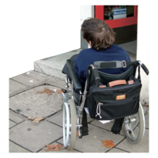

* Do all staff know about **Reasonable Adjustments** and their duty to make these?
* Do all staff know what a reasonable adjustment is and what this may look like in their role?
* Do all staff know where and how to flag any reasonable adjustments they have identified for a person on their record in order to ensure all other staff in the practice can also use this?
* Please watch this video about the importance of making reasonable adjustments within your practice
* [Reasonable Adjustments](https://www.youtube.com/watch?v=gUHHoZZcUTo&feature=emb_title)

T E A C H

# In This Section we help to embed an understanding of reasonable adjustment requirements using our acronym T.E.A.C.H.

Under the **Equality Act 2010**, every health provider has a duty to make reasonable adjustments to bridge the health inequalities. In Hertfordshire, the Learning Disability Health Liaison Team developed the acronym TEACH to help you consider all the different ways in which you may need to make reasonable adjustments.

Reasonable adjustments need to be made at **ALL** stages of health care delivery from the person being able to make an appointment through to clinicians referring on.

Here are the Letters of **TEACH** and short video clips to watch.

|  |  |
| --- | --- |
|  | **Time -** This might be offering a double appointment if additional time is needed. It may mean offering an appointment at a specific time of day that the person is likely to be more receptive at. It may mean booking a few short appointments to build up the persons trust before attempting any health investigations.  [LD awareness - TIME](https://www.youtube.com/watch?v=_eIB8V-PF2A) This is a clip where Gavin and Hilary talk about the impact of using TIME as a reasonable adjustment. |
|  | **Environment** - This might mean meeting in a different place if the health environment causes undue distress e.g., appointments at home or even in someone’s car. It may mean the person needs a quiet waiting area or even needs to wait outside and be telephoned to come in when its time.  [LD awareness - ENVIRONMENT](https://www.youtube.com/watch?v=6Cl2lqOhWEc) This is a clip where Gavin and Hilary talk about the impact of and ways to adapt the Environment as a reasonable adjustment. |
|  | **Attitude** – This isn’t just about treating everyone with dignity and respect but is also about valuing everyone’s life equally. If a person isn’t accepting medical treatment or examinations, then the medical practitioner needs to be considering their mental capacity to understand WHY the treatment/investigations is being recommended and the possible RISKS of not having it.  It’s having the attitude to find solutions to the obstacles that the persons learning disability puts in the way of them receiving an equitable health service. If they don’t have capacity to understand weigh up the risks of their refusal then a best interest decision must be made, ensuring every step possible has been taken to meet their health needs.  [LD awareness - ATTITUDE](https://www.youtube.com/watch?v=ad1oM4QcnoI) This is a clip where Gavin and Hilary talk about the impact of and ways to adapt your attitude as a reasonable adjustment. |
|  | **Communication** - This means using accessible information to enable understanding e.g., Easy Read leaflets, pictures, symbols, or sign language and using the Purple Folder to both read back and record. The purple Folder will enable health professionals to understand the person’s baseline to assess changes in their health that they may not be able to verbalise. [Think Simon Sock Story] Communication is nearly ALL about body language too. If you don’t give off an aura of safety, warmth, and friendliness then the person is unlikely to accept any physical examinations from you.  [LD awareness - communication](https://www.youtube.com/watch?v=ioXQjktOe8o&t=1s)  In this video clip Gavin explains how that very first call to a surgery of health setting can be the difference between him attending and not attending a health appointment.  [LD awareness - Communication](https://youtu.be/_e3zefo4KzM) This is a 25-minute video where Gavin and Hilary demonstrate ways to adapt your communication using the **top 10 communication tool** on the next page. |
|  | **Help** - This means listening to others (Carers, parents, people who support the person in society and partners) THEY are the experts in the person and may have essential information to help you build the jigsaw puzzle of diagnosis. Also, HELP is about seeking help or advice from specialist services when you have concerns or are unable to find solutions to meeting the persons health needs (e.g., Community Learning Disability Nurse or Social Worker).  [LD awareness - HELP](https://www.youtube.com/watch?v=HqxtKVJX18I) This is a clip where Gavin and Hilary explain the reasonable adjustment of Help – and the impact of using the HELP of others to build the diagnostic picture and reduce the risk of delays in diagnosis. |

These Top Ten Tips for Communication can be downloaded from the website LD Professionals Section [www.hertfordshire.gov.uk/ldprofessionals](http://www.hertfordshire.gov.uk/ldprofessionals)

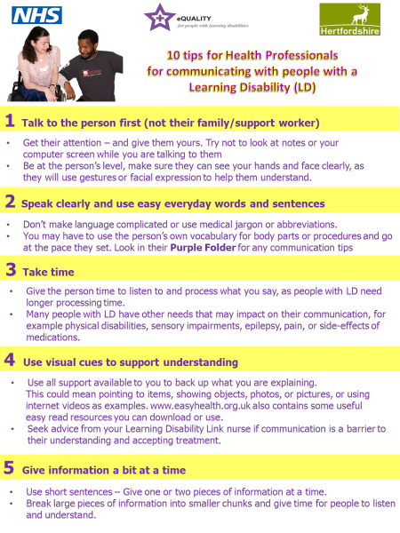

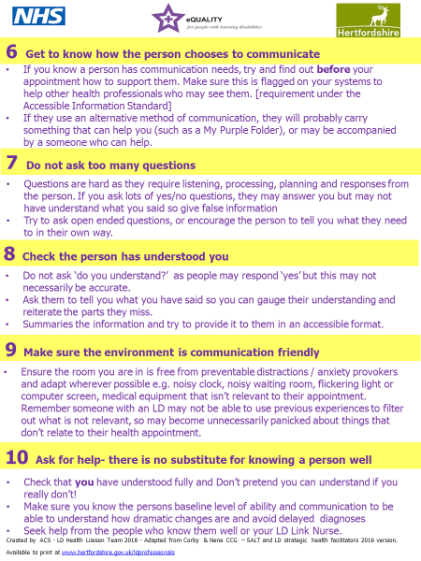

* The video mentioned in TEACH [Reasonable Adjustments - Communication](https://youtu.be/4Nik-aF7i6s)

also aims to help you put into practice these top 10 tips!



**A Harry Potter Reasonable Adjustment**

**A man with a learning disability who refuses all medical interventions has found a way of accepting them through his love of Harry Potter.**

**With most medical decision he does not have the capacity to fully understand the risks of his decision to refuse treatment and so Best Interest Decisions must be made.**

**He recently reached a point that his refusal to have his toenails cut was impacting his ability to wear shoes and walk.**

**The GP was weighing up whether it was in his best interest to have a general anaesthetic as his behaviours meant he would not accept any podiatry support whilst awake.**

**The risk of infection and inability to mobilise was a tough decision to weigh up against the risk of anaesthetic.**

**Then, one of our learning disability nurses discovered his passion for Harry Potter and started to think outside the box.**

**With good communication, a bit of creativity, a bit of wizardry attire, a couple of wands and an open- minded podiatrist, they were able to set up his Hogwarts podiatry within his flat and all assumed different Harry Potter characters. It took time, but they worked their ‘magic’ without any need for risky anaesthetic.**

A great example of least restrictive approaches to best interest decision making.

**So … when someone asks you to talk about Dogs to help a person remain calm or asks you to see them in the car instead of the consulting room, think of Harry Potter and stick on whatever the metaphorical wizard hat is, that is required to get equitable health outcomes for YOUR patient.**

**Talk and Make a Pledge – Criteria 3**

* What reasonable adjustments do you make?
* Have you watched all the video clips?
* What story impacted you most, and why?
* What extra steps within your role can you take?

CRITERIA 4

The Purple Folder

* What do you know about the Purple Folder?
* Does your practice use it effectively?
* Do you know what the purpose is of the Purple Folder and how it helps reduce health inequalities?
* Do you know how people can download / request the new improved pages?

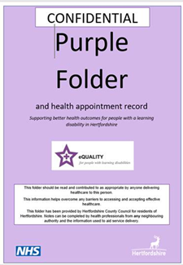

What is ‘The Purple Folder’?

This section embeds the importance of health passports, specifically the Purple Folder.

The purple folder is Hertfordshire’s health passport that is available to adults with learning disabilities living in Hertfordshire or registered with a Herts GP surgery. Please click on the link below or visit our website for more detail. Good use of the Purple Folder can reduce the risk of delays in Diagnosis due to communication barriers or reluctance to accept investigations or treatment. It should be used by ALL health services in Herts when a patient attends an appointment. If someone with a learning disability says they do not have one, all health services should encourage them to get one.

[www.hertfordshire.gov.uk/LDmyhealth](http://www.hertfordshire.gov.uk/LDmyhealth). The new pages can be downloaded here

**How will it help?**

The Purple Folder provides health professionals with a holistic overview of the

* Person’s health and their baseline abilities
* Recent history of other Health professional’s involvement to help build a diagnostic picture
* **The reasonable adjustments** that need to be made by the health service to ensure equitable health outcomes are achieved without delays in diagnosis and treatment
* **The Communication needs** of the person to both ensure they understand and can make informed choices as well as to ensure you, as health professionals, know whether they are communicating pain or ill health (e.g., one lady screams and bites her hand and this indicates she is excited and happy. Another lady screams and bites her hand and this indicates she is in excruciating pain)
* The level of support the person needs to enable them to successfully access healthcare services
* The support level they would need with personal care, eating and drinking should they be admitted to hospital

It is a tool that can support you, as a health professional, to confidently communicate and work with an individual in the most appropriate manner for them. It is a requirement under the **Equality Act** to make reasonable adjustments and a requirement under the **Accessible Information** **Standard** to use a person’s preferred means of communication. The purple folder is deemed to be a health document and therefore, if the information is within the Purple Folder and a health service does not utilise it, they could be questioned over their compliance with these two legislations. The Purple Folder is there to help.

**What should you do when someone brings their Purple Folder to your service?**

1. If there are any barriers to you being able to give them the same healthcare you would anyone else, check the reasonable adjustments section and communication section to see if there are things you can try that their carer hasn’t told you.
2. If you discover something that helps the person e.g., if I talk about dogs he calms and then he trusts me and engages with healthcare, then make sure this is added to the reasonable adjustment’s sections so others in the future can use this top tip too.
3. If you are unsure whether they are in pain or of the severity of their illness, read the ‘**how I behave when I am well / unwell’** pages to see if they are likely to be non-verbally communicating more extreme symptoms than you can establish. Also, check the baseline measurements that are recorded in the folder to see how far off baseline they are.
4. If the person has come without support, then complete one of the blank pages called **‘The Health Plan after Todays appointment’** and write in clear and simple language.
5. After an Annual Health Check, make sure the Health Check action plan is stored in the annual health check section and you have a record on the annual health check record page. If the baseline measurements page hasn’t been updated, then add any that have been taken at the annual heath check and remind the person the annual update of the purple folder is due at annual health check time.
6. Always write a very brief summary in the health appointment record.

**The Health Appointment Record**

This should be written on by **ALL** the health professionals who see the person. It only needs a brief outline of the appointment and actions. This will help gain an overview of all health interventions the person may be currently receiving to aid diagnostic decisions. The records should be kept in chronological order to make this easier for you.

An example of good use of this was a gentleman who started having falls, he became unsteady on his feet, disengaged, slept more, uninterested in the TV and his books. The GP did **NOT** look at the appointment record pages and went down the pathway of neurology and possible dementia. The neurologist **DID** look at the record and identified a sudden onset of these changes in February. It was identified he had seen an optician in February and been given a new prescription for glasses… this prescription was completely wrong. All the symptoms related to not being able to see. This would have been identified and resolved a lot earlier had the GP read records.

**Getting a NEW 2023 Version of the purple folder.**

Whether someone has never had a Purple Folder or have an old version [Old versions will say MY purple Folder … new ones say Purple Folder]

**They are all entitled to a new Version.**

All pages are available on the website here [www.hertfordshire.gov.uk/purplefolder](http://www.hertfordshire.gov.uk/purplefolder) for the person to complete electronically online and print and add to their folder. To receive folder and inserts they can contact us on**01438 845372** or email [purplefolder@hertfordshire.gov.uk](mailto:purplefolder@hertfordshire.gov.uk)

If you think the person does not have a support network to help them complete the Purple Folder, then please let us know and we will support them. We will ask you the key Reasonable Adjustments and Communication approaches that you have established with the person to ensure these are in their folder.

**Our Pledge**

**record your services pledge for what you will change in your practice to ensure better use of the Purple Folder**

**Purple Cards**

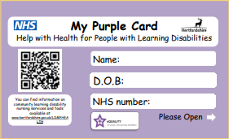We have also created purple cards that can be stored in a person’s wallet and contain the core information on reasonable adjustments, communication needs and help with health. These are a useful addition [not replacement] to the purple folder for people who are more independent and may be out and about and not have their purple folder with them. Do you have patients who would benefit from this? Email [purplefolder@hertfordshire.gov.uk](mailto:purplefolder@hertfordshire.gov.uk)

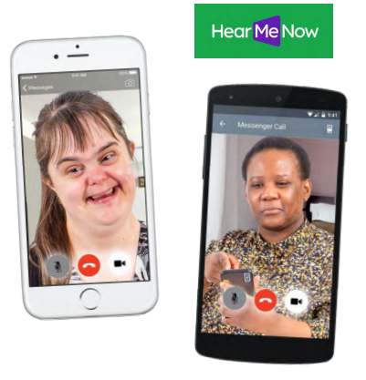

**Me on My Best Day**

We have a campaign to encourage all people with a learning disability to film a 20 second video showing what they look, behave, and communicate like when they are well. This is to help health professionals understand how far off their baseline they are. Can you ask your patients to make sure they have one of these on their phone? Here is a link to a video we made to help explain these.

*This clip has about the Purple Folder, the Purple Card and Me on My best day in it:*

[*Bitesize Learning Disability Awareness for health Professionals No. 8– Help*](https://www.youtube.com/watch?v=HqxtKVJX18I)

For some examples of this, have a look at The Purple All-Stars video [Me on my best day](https://www.youtube.com/watch?v=oA-RP4JPmz8)

**Talk and make a pledge – Criteria 4**

What have you learnt about asking to see Using Me on My Best Day videos?

What have you learned about the purple folder and Purple Cards?

Why do you think it is important?

Record your services pledge for what you will change in your practice to ensure better use of the purple folder

**CRITERIA 5**

**Accessible Environment**

* Are all staff aware of the sensory overload impact that some people with a learning disability and autistic people experience?
* Do all staff know what signs to look out for and what to do?
* Is there anything that can be done to reduce the sensory overload of the physical environment?
* Are key health information and leaflets in easy read?
* Is everyone aware of the impact they can have as part of the environment?

To start this section please re-watch the 8-minute video

E for Environment in TEACH

Here is the Link again[**5. LD awareness - ENVIRONMENT**](https://www.youtube.com/watch?v=6Cl2lqOhWEc)

**Sensory Overload of the Environment**

Sensory overload is very common in people with a learning disability and autistic people.

Just being able to climb in their shoes and imagine what YOUR environment may feel like for them will help YOU to know how to help them.

Remember that they MAY not be able to filter out things that aren’t relevant to them.

* **ALL** noises may sound excessively loud – there may be sounds so familiar to you that you don’t hear them, like the beep of the appointment machine or the growl of the blood pressure machine
* **ALL** images on the wall may be leaping out at them
* **ALL** equipment and furniture MAY be alarming if its unfamiliar to them
* **ALL** smells will impact their stress levels, especially unfamiliar smells



**Imagine ….**

You have been zapped into the sky and dropped in a room on another planet … imagine how you would be trying to instantly take in everything around you and assess the risk and fear… how would you feel?

Your heart is racing, your eyes are darting around, you are shaking, you start to cry, something totally unfamiliar approaches you … you jump, you scream. They move to touch you … You hit out and run, run, run but there is nowhere to go … you start knocking things over in your desperate plea to find a safe place…

**This is Fight or Flight mode …. If someone’s behaviour is challenging … they are probably in fight or flight mode …, what are they communicating and what can you do to answer that communication and help them feel in that safe place?**

You could…

* Seek the guidance of those that know the person well to see what they think will help
* Mirror their actions of reassurance
* Ensure your body language, tone and facial expressions are giving an aura of kindness, caring, and understanding … not fear, frustration and wanting them to go…
* Take Time to allow them to come out of fight or flight mode and feel secure in your company
* Remember … it’s Not behaviour … its Communication
* **When someone struggles with your environment,**
* **it’s time to think outside the box-here are some examples:**
* A man is always seen in the car outside the front of the GP surgery. This is where he feels safe and will allow first level of investigations to happen. If further things are needed then a best interest decision can be made as to how to progress, but without this stage everything would remain undiagnosed.
* A man who hates waiting rooms and noise, wears his headphones and waits in the car and then goes straight into the GP room when it’s his time
* A lady who brings her dog because she is only calm when her dog is with her. Reception staff stand with her dog outside when she is called in to the appointment
* A lady who likes the waiting room as she likes to look at the fish… but hates it when its noisy, must have appointments at the beginning of surgery when it is quiet and has a chair facing the fish tank ready… she will then relax and engage with the GP

**Finally – Think about the Equipment and Information available to patients …**

****Do you have key information available in easy read for your patients with a learning disability?

Do you have Purple Folder information?

Do you have ‘How to make a complaint’ in easy read?

Do you have info on Annual Health Checks in easy read?

Do you have information on people with a learning disability being entitled to the free flu vaccine?

*There are resources on all these available on the website* [*www.hertfordshire.gov.uk/ldprofessionals*](http://www.hertfordshire.gov.uk/ldprofessionals)

**Talk about and Make a Pledge – Criteria 5**

What, in your role, can you change in relation to the environment?

What from the video or information here has resonated with you and made you think about adapting your approach?

**CRITERIA 6**

**Annual Health Checks and LD My Health Tools**

[**Annual Health Check Preparation Form**](https://www.hertfordshire.gov.uk/media-library/documents/adult-social-services/learning-difficulties-and-dementia/professionals/annual-health-check-preparation-form-v5-april-24.docx)

[**Stay Healthy at Home Checklist**](https://www.hertfordshire.gov.uk/media-library/documents/adult-social-services/learning-difficulties-and-dementia/stay-health-at-home.pdf)

* Who is responsible for making sure your annual health checks are completed?
* What do you do to encourage people to attend who don’t respond?
* Are you using the health check action plan to enable health awareness 365 days a year?
* Are you encouraging use of the easy read health awareness tools?
* Is everyone in the practice aware of the requirements of an annual health check and your surgeries processes?

**Annual Health Checks**

# This section refreshes the important role that the annual health check provides in reducing health inequalities.

# With tools and examples to help you provide high quality service.

[**System one - annual health check template**](https://www.hertfordshire.gov.uk/media-library/documents/adult-social-services/system-one-ahc-action-plan.docx)

[**Emis action plan**](https://www.hertfordshire.gov.uk/media-library/documents/adult-social-services/emis-ahc-action-plan.pdf)

[**Emis instructions**](https://www.hertfordshire.gov.uk/media-library/documents/adult-social-services/emis-instructions-ahc-ld.pdf)

[**Vision annual health check template**](https://www.hertfordshire.gov.uk/media-library/documents/adult-social-services/vision-ahc.docx)

Annual health checks are important, as many people with a learning disability may have difficulties in recognising illness or communicating their needs.  Reduced communication skills mean that for some people with a learning disability, they may not be able to explain a change in how they are feeling or pain.  They may not fully understand that these changes may have a significant impact on their health if they are not assessed.

Dr Vicky McCulloch, LD Lead GP for HVCCG

Everyone with a learning disability aged 14 and older can get an annual health check at their GP surgery.

The national requirement is for 75% uptake of annual health checks for people on GP learning disability registers. But we need to make sure that ALL people on your learning Disability register are enabled to access this as it will be the 25% who don’t respond who are most likely to have the unmet health needs which could lead to the health inequalities identified by LeDeR.

The Purple Star Nurse can support with welfare visits and contacts with ‘Hard to Reach’ people where the surgeries LD Champions have tried all other means to encourage these people to attend.

**Minimum Standard for Learning Disability Annual Health Checks**

Taken from NICE guidelines P17/18 points to the NICE Quality Standard 187 to provide the quality standard for learning disability health checks. All checks should be auditable against this standard.

[Quality statement 4: Annual health checks](https://www.nice.org.uk/guidance/qs187/chapter/Quality-statement-4-Annual-health-check)

**Purple Star advice**

Based on the Quality Standard, the Annual Health Check should be carried out by a clinician(s) that has/have the competencies to meet this minimum standard. This may be a collaboration of different team members but the final sign off must be by an accountable clinician.

There have been **LeDeR** death reviews where the competency of the clinician delivering the AHC has been questioned, as the record showed clear health indicators that were noted but not actioned by the clinician, as they didn’t have the clinical knowledge. Therefore, it is always advised that the content of the AHC is signed off by a clinician who is competent in all areas of this minimum standard.

**Annual health check for people with a learning disability**

An NHS initiative for adults and young people aged 14 and over with a learning disability to provide additional health support and help identify health conditions that could otherwise go undetected.

The enhanced scheme for providing annual health checks for GPs specifies details of the checks required, including that they should be undertaken by an appropriately trained provider and based on a protocol that, as a minimum, covers:

* + A collaborative review of physical and mental health with referral through the usual practice routes if health problems are identified. This includes conditions such as epilepsy and dysphagia.
  + A specific syndrome check.
  + A check on the accuracy of prescribed medications.
  + A review of whether vaccinations and immunisations are up to date, for instance seasonal influenza, pneumonia, or hepatitis B.
  + A review of coordination arrangements with secondary care.
  + A review of transition arrangements if appropriate.
  + A discussion of likely reasonable adjustments should secondary care be needed.
  + A review of communication needs, including how the person might communicate pain or distress.
  + A review of family carer needs.
  + Offering support to the person to manage their own health and make decisions about their health and healthcare, including through providing information in a format they can understand and any support they need to communicate.

**Health action plan**

A personal plan for people with a learning disability about how to stay healthy. It should detail what help and support the person needs to look after their health. This might include support to manage physical or mental health conditions, or actions to improve their lifestyle, such as changes to diet and exercise.

***Purple Star Advice***

We have created a document called the [Stay Healthy at Home Checklist](https://www.hertfordshire.gov.uk/media-library/documents/adult-social-services/learning-difficulties-and-dementia/stay-health-at-home.pdf)which, if used for ALL people as one item on their health check action plan, will take steps to ensure the person is having their core health changes monitored at home. We recommend this action as a minimum standard on all Health Check action plans.

‘Ask the people who support you to download the [Stay Healthy at Home Checklist](https://www.hertfordshire.gov.uk/media-library/documents/adult-social-services/learning-difficulties-and-dementia/stay-health-at-home.pdf) and follow the guides in this to make sure you know how to look after your health. If you do not have anyone to help you with this, you can call the learning disability nursing service on 01438 844 681 or tell us at the surgery and we can contact them for you.’

**REMEMBER** – The Learning Disability Nursing Service is here to help you with your ‘Hard to Reach’ patients or any that you feel won’t be able to meet their health Check Actions due to limited / concerns around their support network. You can contact us for Annual Health Check Support via [purplestarstrategy@hertfordshire.gov.uk](mailto:purplestarstrategy@hertfordshire.gov.uk)

[RCGP - Royal College of General Practitioners](https://www.rcgp.org.uk/)

[RCGP - Health checks for people with learning disabilities - toolkit](https://www.rcgp.org.uk/clinical-and-research/resources/toolkits/health-check-toolkit.aspx)

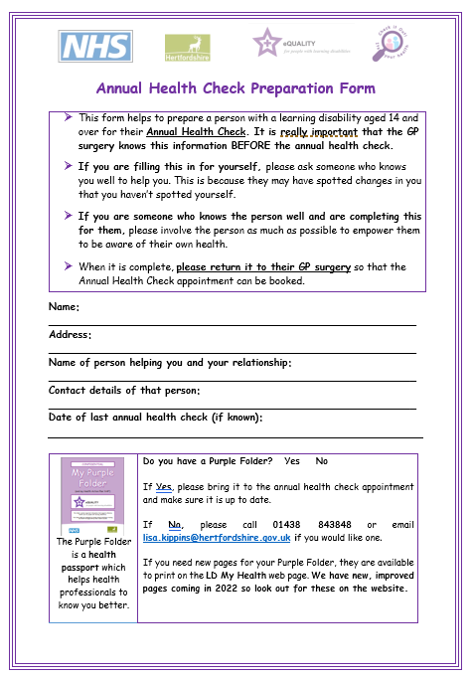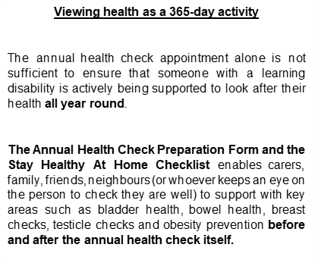

**Health Check Action Plan**

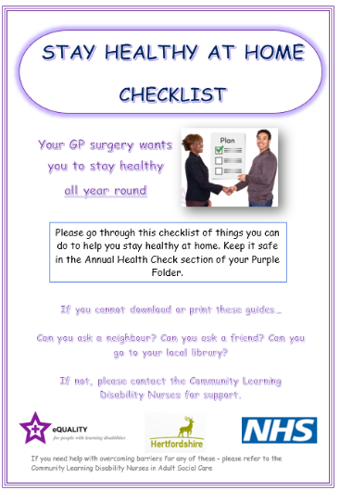

* A health check action plan must be issued after the annual health check and should follow the national template on the surgery’s system
* [The Stay Healthy at Home Checklist](https://www.hertfordshire.gov.uk/media-library/documents/adult-social-services/learning-difficulties-and-dementia/stay-health-at-home.pdf) should be included as part of the Health Action Plan so that patients and the people who support them can download and print the LD My Health guides. It should be printed and given to each patient at the end of their annual health check which they can then file in their Purple Folders

**Learning Disability - My Health Guides**

We have created a stay healthy at home checklist and this links to some of the important Learning Disability Health Guides that are available on [LDmyhealth](http://www.hertfordshire.gov.uk/LDmyhealth)

These are important to promote, as health awareness is a 365 day a year activity and using these tools at home could make a difference between living and dying.

**Keith’s Story**

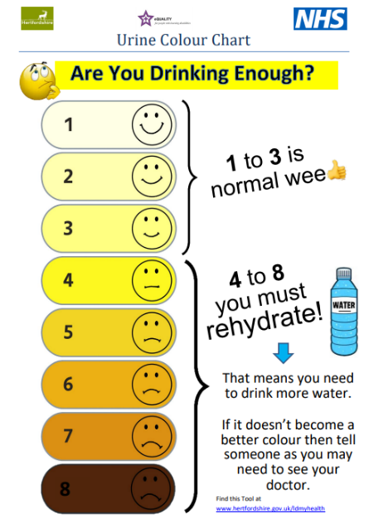

Keith is an autistic gentleman and uses non-verbal communication. He is very private and is independent with toileting. One day, he pointed to the very dark, concentrated urine as shown on number 8 of the *Know Your Wee* guide to one his support workers. The support worker was rightfully concerned and informed Keith’s GP. Following some tests, he is now being treated for bladder cancer. Without this guide, this symptom would have been missed. Keith’s diagnosis could have been delayed further and may not have been identified at all. Bridging the communication gap was key to getting the right support Keith needed.

Here are some other examples and links to the tools:

Use the ‘Know your Breasts’ Guide on the community learning disability nurse’s website to be able to keep a regular check on your own breasts and know when it is important to see the doctor, this is important for everyone. You can self-refer to the learning disability nurses if you need extra help or advice.

Check your breasts in the how to stay healthy section <http://www.hertfordshire.gov.uk/ldmyhealth>

Use the ‘Know your Testicles’ Guide on the community learning disability nurse’s website to be able to keep a regular check on your own testicles and know when it is important to see the doctor, this is important for everyone. You can self-refer to the learning disability nurses if you need extra help or advice.

Check your testicles in the how to stay healthy section <http://www.hertfordshire.gov.uk/ldmyhealth>

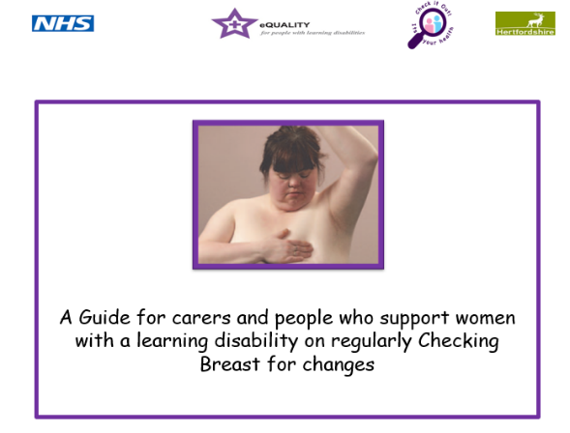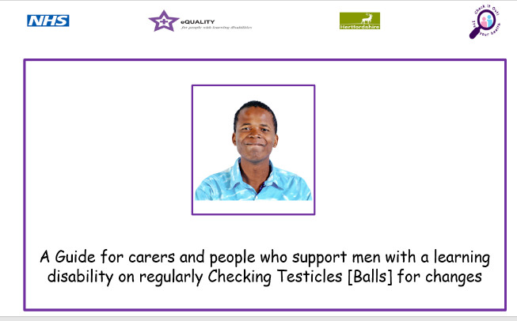

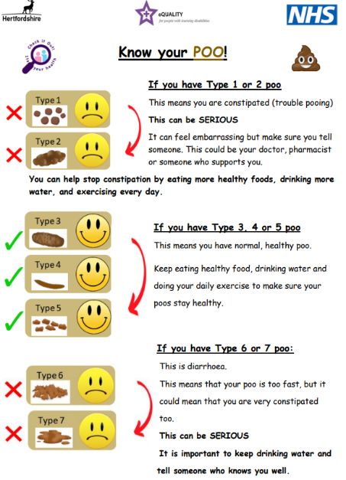

**[Constipation](https://www.england.nhs.uk/wp-content/uploads/2019/05/constipation-resources-easy-read.pdf?msclkid=69cf5f2ca9ba11ec8979bf428a508390)**

**[Video about healthy poo](https://www.youtube.com/watch?v=9Wv87x9ho9s)**

**Resources to help your practice**

**Easy Read Checklist**

This checklist can be used by patients within the annual health check to ‘tick off’ certain areas of their health they may wish to discuss with the doctor/nurse seeing them. It can be used as a reminder to patients to discuss an issue/concern during the appointment or as a method of supporting carers to prepare the person for the appointment.

**Easy Read Invitation Letter**

This letter explains why the annual health check is important and informs the patient and/or carer about the importance of returning the completed AHC Preparation Tool prior to the face-to-face appointment being booked. This will help all information to be gathered and reviewed by the AHC clinician in advance.

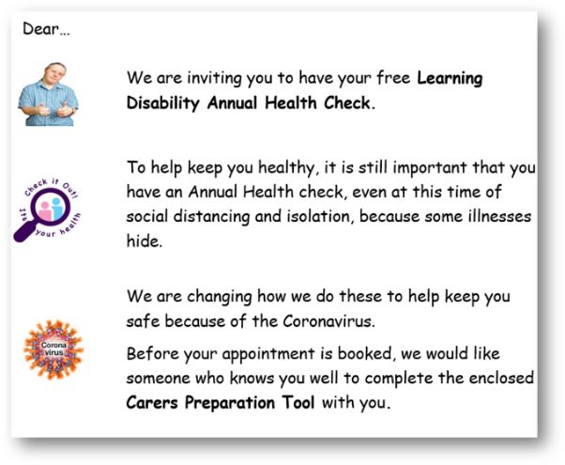

**Sharing Communication Preferences/Reasonable Adjustments Form**

This form is to be completed by the patient/their carer so that invaluable information is gathered about their communication preferences and reasonable adjustments (see criteria 3). This could make the difference between a person attending their appointment and how engaged they will be throughout.

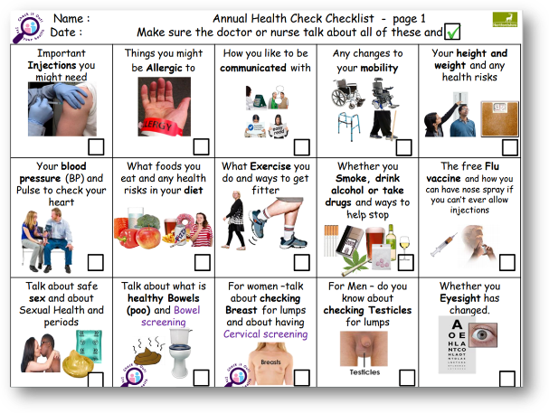

**Find out more…we can help!**

Here is a video of an annual health check to help explain

the latest process for surgeries to follow:

[How to do a good annual health check](https://www.youtube.com/watch?v=lEEpias8OVA)

For more support/training with the latest annual health check process, contact:

[sarah.sullivan@hertfordshire.gov.uk](mailto:sarah.sullivan@hertfordshire.gov.uk) (Purple Star Nurse) for surgeries accredited with a Purple Star.

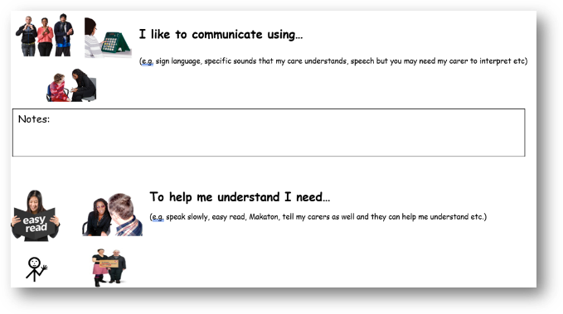[megan.moorhouse@hertfordshire.gov.uk](mailto:megan.moorhouse@hertfordshire.gov.uk) (Health Equality Nurse) for surgeries not yet accredited with a Purple Star.

[edi.curran@hertfordshire.gov.uk](mailto:edi.curran@hertfordshire.gov.uk) for general enquiries which will then be discussed by the team.

All forms and documents can be found at: [www.hertfordshire.gov.uk/LDmyhealth](http://www.hertfordshire.gov.uk/LDmyhealth)in the **Annual Health Check** section.

**Preparing for a healthy adulthood**

Everyone aged 14 or over with a learning disability should be offered an annual health check, we have done some work to help people in their early teens and the people who support them be more health aware. Here are links to the work we have done that you can share with any parents/teenagers with learning disabilities or difficulties.

Please read the ‘preparing for a healthy adulthood guide and watch the videos – this will help you to be able to see the value of the content and remember to share with parents and carers of anyone aged 11 and over who has a learning disability or difficulty



**[Preparing for a healthy adulthood](https://www.hertfordshire.gov.uk/microsites/local-offer/media-library/documents/preparing-for-a-healthy-adulthood-final.pdf)**

A guide for Parents, Carers, School Nurses, Teachers, Tutors, Special Educational Need Coordinators, Paediatricians and Social Care Staff to help children and young adults with additional needs to understand how to look after their health.

**[Preparing for healthy adulthood - chapter 1](https://www.youtube.com/watch?v=8qtcKDHK10M&t=380s)**

In chapter 1 we will be explaining the terminology that is used in adult health services and learning more how to use the learning disability screening tool.

[**Preparing for healthy adulthood - chapter 2**](https://www.youtube.com/watch?v=1K6YKHk_rYA)

In chapter 2 we will be talking about the services and tools available to support a person with a learning disability, including annual health checks, My Purple Folder & My Health Information pages.

[**Preparing for healthy adulthood - chapter 3**](https://www.youtube.com/watch?v=obFOuL33jCc)

In chapter 3 we will be talking about how you can use the TEACH acronym to identify reasonable adjustments and support improving health outcomes for a person with additional needs.

[**Preparing for healthy adulthood - chapter 4**](https://www.youtube.com/watch?v=Lm1PnEHKObI)

In chapter 4 we will be sharing a range of health resources that are available within the guide to help a young person with additional needs become more aware of their own health needs.

[**Preparing for healthy adulthood - chapter 5**](https://www.youtube.com/watch?v=rmKDwXG44YY)

In chapter 5 we will be talking about adolescence, puberty, and wellbeing and how you can help support a young person with additional needs through this transitional stage.

[**Preparing for healthy adulthood - chapter 6**](https://www.youtube.com/watch?v=x5LHrU-_nAw)

In chapter 6 our experts by experience will be sharing their experiences on how you can help prepare a young person to be more accepting of health investigations and interventions.

**Collaborative working between the GP/Nurse/HCA, Admin, Carer, Patient and Health Liaison Team**

**=**

**Positive health outcomes and reduced health inequality**

**Talk about and make a pledge - Criteria 6**

Have you seen and do you use the AHC preparation form and Staying Healthy at Home Checklist?

Why do you think an Annual Health Check is important for someone with a learning disability?

Does your practice create health check action plans, encouraging health awareness all year round?

Within your role, what can you do to help with the annual health check process?

**CRITERIA 7**

**Flu and Covid Vaccines**

* Are you aware that everyone with a learning disability is entitled to the flu vaccine for free?
* How do you invite your LD patients?
* How do you follow up with those that don’t attend to check they understand how important this is?
* Do you try and find reasonable adjustments to overcome barriers to people accepting the injection?
* Do you contact the learning disability nurses when you need further support with overcoming barriers?

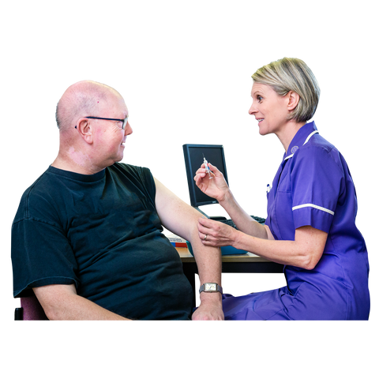**Flu Vaccine**

The LeDeR report states that respiratory problems are the leading cause of death for people with learning disabilities. It is important that people with learning disabilities receive the Flu Vaccine.

* All people with learning disabilities are eligible for the **free** flu vaccine.

[Easy read on having a flu jab](https://www.hertfordshire.gov.uk/media-library/documents/adult-social-services/learning-difficulties-and-dementia/easy-read-flu-info-with-nasal-spray.pdf)

* The national requirement is for 60% uptake of flu vaccines of people on GP learning disability registers
* If they are reluctant to have it then you need to consider Reasonable Adjustments
* [How to plan any reasonable adjustments](https://www.hertfordshire.gov.uk/media-library/documents/coronavirus/acs-letters-and-faqs/covid-ra-leaflet-v5-29.1.21-final.pdf)
* People with a learning disability can have the flu vaccine via nasal spray as 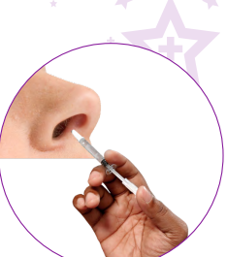an alternative if they will not accept it by injection (this is not licensed for use in adults but can be given ‘off label’ if the person won’t have it by injection.)
* [Easy read information flu vaccine with nasal spray](https://www.hertfordshire.gov.uk/media-library/documents/adult-social-services/learning-difficulties-and-dementia/coronavirus/8.-master-easy-read-flu-info-with-nasal-spray-v2-07.06.21.pptx)
* You can contact the Purple Star Team or your Link Nurse if you would like support with improving your uptake of flu vaccinations for your patients with learning disabilities. [purplestarstrategy@hertfordshire.gov.uk](mailto:purplestarstrategy@hertfordshire.gov.uk)

**Covid Vaccine**

Below is a short video of Gavin, our expert by experience, explaining why it is important to get the Covid vaccine.

[Gavin says 'Get your Covid-19 vaccination'](https://www.youtube.com/watch?v=3HRKQ-8eAIE)

We also have various easy read information available on our website.

[Easy read information about having your Covid-19 vaccine](https://www.gov.uk/government/publications/covid-19-vaccination-easy-read-resources)

**Remember**! everyone over the age of 18 needs to make the decision regarding their health treatment for themselves and this includes vaccines.

If they do not have the capacity to weigh up the risks and benefits of the vaccine and are refusing because they ‘don’t like needles’, then this is **NOT** declining the vaccine.

Carers and Family members **CANNOT** legally make the decision to decline for the person [unless they hold lasting power of attorney for health and welfare].

This decision is a medical decision that needs to be made by their GP practice, in the persons best interest.

**Talk about and make a pledge – Criteria 7**

What percentage uptake does your practice have for Flu and Covid vaccines for your learning disability patients?

What steps do you take to reach those reluctant people / non responders?

Do you have people marked as ‘declined’ when they may not have capacity to make decisions in an informed way?

**CRITERIA 8**

**Accessible Information Standard 2016**

* Do all staff know what their role is with Accessible Information Standard?
* Does the practice make steps to ensure their service is accessible from booking an appointment right through to delivering clinical care?
* Do you have a process to ensure accessible information is shared when referring on?

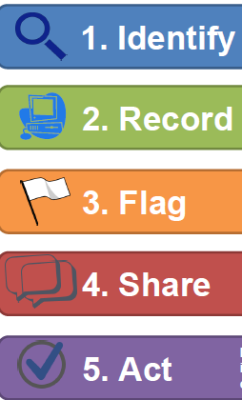**Accessible Information Standard 2016**

How to put accessible information standard into your practice.

It is a legal requirement for all health and social care providers to identify, meet and share the information and communication needs of people who use their service.

For people with a learning disability - The Accessible Information Standard requirement means all health and social care providers need to:

**IDENTIFY** – Ask all patients/service users how they like to be communicated with. Consider if this would affect how information is sent to them for example, do they prefer phone calls?

**RECORD** – Make sure you tell the patient and get **agreement** from them that this information will be recorded on your system, and on their Summary Care Record Additional Information. The patient (or family/carer) must agree to the exact wording used for this record.

**FLAG** – This information MUST be flagged on your system and on the Summary Care Record Additional Information so ALL professionals KNOW how to communicate with this person and can access this information easily and instantly.

**SHARE** – Whenever referring this person to other professionals or liaising with other professionals you MUST notify them of the persons preferred method of communication, using the agreed wording.

**ACT** – Make sure that you always follow the communication method requested and recorded.

**CIPOLD (2013)** found that a large contributing factor to the health inequalities faced by people with learning disabilities is delays or failings to attend health appointments due to not receiving information in an accessible format that the person could understand. By adhering to the Accessible Information Standard, this ensures that professionals are reducing this risk factor for people with learning disabilities.

[C - Communication](https://www.youtube.com/watch?v=_e3zefo4KzM&t=47s)   This is the video link from the Communication section in TEACH – But watch it again… in this Gavin describes how he would never get to an appointment unless people knew HOW to get him there… he would be a DNA -Did Not Attend person without his Accessible Information being flagged, shared, and used.



**Think about your website –** do you have easy links to information for your learning disability patients? Remember – if you get it right for people with a learning disability, you get it right for everyone… Everyone likes bitesize simple information.

**Think about your appointment process** – Does it work for people with a learning disability who may not have someone to help them? How complicated is the press 1, press 2 processes? Do you have a designated line that bypasses that process for the patients who would find the appointment process a barrier to getting healthcare?

**Think about your triage -** does the triage person look at their reasonable adjustments and accessible information requirements and adapt the questioning? Remember a person with a learning disability may Not be able to summarise the essential points for the call to be triaged? Some surgeries automatically triage to make an appointment for people who are known to struggle to communicate their health need effectively.

**One man called the surgery and said he needed to see a doctor because he couldn’t tie his laces… the receptionist asked more, but used leading questions and asked if it was because of his hands? The appointment was triaged as not urgent.**

**The man couldn’t tie his laces because he was breathless and had oxygen stats of 90% … He didn’t know how to explain why he couldn’t tie his laces so agreed that it was his hands… so much can be missed in how the person prioritises what they need to be seen for.**

Using your Admin Champion to build the grid of key information on all your LD register patients [we talked about in the Annual Health Check Criteria] can make a **HUGE** difference – this whole team approach to accessibility of information can be the difference between receiving timely health care and reducing deaths due to delays in diagnosis.

**Talk about and Make a Pledge – Criteria 8**

What has resonated with you in this section?

What can you change in your personal practice to reduce the impact of accessible information stopping access to healthcare?

What changes can your service make that will help?

**CRITERIA 9**

**Safeguarding**

* Do all staff know of their responsibility to spot **ANY** signs of possible safeguarding and how to report it?
* Do they understand that even small things may be part of a much bigger picture?
* Do they know how and who to tell if they have a concern?

**Here are the online portal and telephone number to report a concern:**

[**Report a concern about an adult - Hertfordshire County Council**](https://www.hertfordshire.gov.uk/services/adult-social-services/report-a-concern-about-an-adult/report-a-concern-about-an-adult.aspx)

**Contact Health and Community Services - 0300 123 4042**

**Safeguarding**

This section embeds how to help safeguard people with Learning Disabilities from abuse.

Safeguarding means protecting people's health, wellbeing and human rights and enabling them to live free from harm, abuse, and neglect. It is fundamental to high-quality health and social care. The main areas of abuse are:

* Physical
* Sexual
* Financial
* Psychological/emotional
* Neglect and acts of omission
* Discriminatory
* Organisational abuse
* Neglect and poor practice
* Self-neglect
* Domestic Abuse
* Modern Slavery

Report **anything** that may potentially be deemed abuse at any level.

Even if it is just an uncomfortable feeling you have, still report it so it can be investigated.

Never put yourself in a position where you could regret not mentioning something.

[Safeguarding](https://www.youtube.com/watch?v=UxWxNLKCe3Q&t=22s) Here is a short video where Gavin talks about safeguarding risks he has been in and other people he knows.

**The murder of Steven Hoskin**

**What happened?**

Steven Hoskin lived alone in St Austell; he had a learning disability placing him at risk of abuse. Steven was 39 years old and was subjected to “harrowing” abuse ending in his death in St Austell, Cornwall on 6 July 2006.

He was forced to swallow a lethal dose of paracetamol, hauled around his bedsit by a dog collar and burned with cigarettes.

Darren Stewart, 29, and Sarah Bullock, 16, were convicted of Hoskin’s murder.

They had made Steven walk to a viaduct and forced him to climb over the edge leaving him holding on for his life. Bullock then made Hoskin fall 30 metres to his death by kicking his face and standing on his hands.

A serious case review and an internal management review, highlighted failings to share information between numerous agencies.

He had been placed in a bedsit by adult social care in April 2005 and he was allocated two hours of help each week, but he chose to cancel the service in August and by September the council closed his case. The serious case review found that Steven Hoskin then “lost all control of his own life” when Stewart and his girlfriend moved in and began to abuse him.

Steven’s decision to end contact with adult social care “was not investigated or explored”, the review found.

**Prior to his death, Steven had contacted different agencies over 40 times, including the police and health and social care agencies to indicate he felt he was in danger, but no report was vocalised by him well enough to be fully acted on. None of these reports were ‘joined up’ to be able to unpick the degree of risk Steven was in.**

**Actions for improvement**

Following the SCR, the following improvements and actions have been taken to improve adult safeguarding practice:

* Improved systems of information sharing and reporting, encouraging a rapid response
* Development of police and ambulance systems to indicate when there are repeat calls from the same people. This enables information to be shared between relevant agencies to develop appropriate, comprehensive responses
* Increased awareness of agencies to be more responsive to signs of suspected abuse where the adult is at risk because of a pre-existing condition. In Steven’s case this was his learning disability

**EVEN IF IT’S A SMALL CONCERN – REMEMBER!**

**EVERY TINY BIT OF INFORMATION YOU SUPPLY MAY BE A SIGNIFICANT PIECE TO A BIGGER PICTURE!**

Here is a video outlining the case study of Steven Hoskin’s murder and what has changed since. It highlights when a safeguarding response is required and what problems persist:

[Have we learned the lessons from Steven Hoskin's murder?](https://youtu.be/PuHkan39KOY)

**Talk about and make a pledge – Criteria 9**

What has resonated with you from Gavin’s stories?

What have you learned from watching the Steven Hoskin video and reading about his murder?

How will this impact your practice?

**CRITERIA 10**

**Mental Capacity and Best Interest Decisions**

* Do all staff understand the role they play in enabling understanding in patients with a learning disability?
* Do all clinicians ensure that, where someone refuses to engage, they have capacity to weigh up the risks of that decision?
* Where someone lacks capacity, do all clinicians make the best interest decision?
* Do all clinicians know that they **CANNOT** accept the parents or carers decision – that this **MUST** be a medical decision

[unless the person holds lasting power of attorney for health and welfare decisions]

**Mental Capacity and Best Interest**

In This Section we try to help embed an understanding of how Mental Capacity and Best Interest is something you do every day – if you decide NOT to do something for someone who doesn’t have capacity to understand what is needed, you have, in effect, made a Best interest decision … so we want to help you to truly understand this law in everyday practice.

**The Mental Capacity Act 2005** sets out the law around supporting people with learning disabilities to make decisions. The CIPOLD report found that poor adherence to the Mental Capacity Act led to premature deaths of people with Learning Disabilities. It is vital that everyone involved in providing healthcare to people with a learning disability understands and follows the Mental Capacity Act.

[Capacity and Best Interest](https://www.youtube.com/watch?v=Mw40MeC9e6g)

Watch this video clip where Hilary and Gavin discuss how mental capacity principles are used in everyday practice.

**ACID Test**

Always think…

If someone without a learning disability came to me with the same **ailment/illness/treatment/need,** what would I be doing and in what timeframe?

If that is not achievable because of barriers due to their learning disability, **THEN** you need to assess their Capacity to understand what is needed and the risk of not doing it.

Then, if they are **NOT** able to make an informed decision with their refusal – you need to clinically act in the **BEST INTEREST** using **LEAST RESTRICTIVE** approaches to get **EQUITABLE** health outcomes.

**Five Principles of MCA:**

1. **Never Assume:** Just because someone has a diagnosis of a learning disability does not mean that they lack capacity on every decision.

Simplify the bare minimum information you would expect ANY patient to understand and explain it in those terms.

You MUST assess for each situation and cannot make a blanket statement that someone with a learning disability does not have capacity. The person’s capacity to understand may be altering with each medical decision, and at different points in their life.

1. **Informed Decisions:** You must make practical steps to support someone with a learning disability to understand and make an *informed* decision. Remember the C in TEACH. If there is minimal risk of delaying treatment and it is felt, with time, they may be able to understand and accept treatment, then give the people who support the EXACT simplified information that you would expect them to understand to be deemed to have capacity.

**THINK CURB**

* **Communicate** – Tell them why you think the investigation/treatment is a good idea and what the risk is if you don’t do it. Get the people who support them to help if necessary. Can the person communicate that they have understood this back to you?
* **Understand** – Check they understand what you have said and again use their person who supports them to help.
* **Retain** – This would be, for example, them repeating back to you what will happen and why, in their own words. Not just parroting or saying ‘yes’.
* **Balance** the decision - Weigh up the information and choice they have made. This would mean they would need to show that they understand the possible consequences of refusing.

**If the person Does NOT have Capacity, it is a MEDICAL best interest decision. Next of Kin and Carers CANNOT consent or refuse consent on behalf of the patient UNLESS they have lasting power of attorney for their health and wellbeing.**

1. **Unwise Decisions:** People with Learning Disabilities have the right to make *unwise decisions*. So, if they can demonstrate that they understand the risk of their decision this is their choice. You can ask people who support them to keep discussing and encouraging them to change their mind, but you cannot make a best interest decision if THEY have capacity in this medical decision.

“I know that the smear test can help make sure I never get cancer there, but I would rather risk dying of cancer than have a smear test’”

1. **Best Interests:** If a person with a Learning Disability has been found to lack capacity about a decision, then a best interests decision needs to be made.

* If it is a small decision with negligible health risks you can make this there and then with the carer (for example, carrying out a physical examination, taking bloods, flu jab, completing annual health check)
* Bigger decisions with bigger health risks need a multi-disciplinary decision

**You do this every day** – you weigh up what is the right course of action for the patient, and you tell them. When they don’t understand, you weigh up, with the people who support the person, how achievable that course of action is and what would need to be done to achieve this successfully… Remember the H in Help. The people in their life are the experts in the person … you are the experts in health … this is Teamwork.

The GP can take into consideration the next of Kin’s views and carers views BUT the carer and Next of Kin CANNOT make the decision. It is a medical decision as to what is in the best interest of the patient. It is ONLY when someone holds lasting power of attorney for health and welfare that someone else can make the decision for the person.

1. **Less Restrictive:** Where possible, always use the less restrictive option.

Example: Someone with a learning disability who is needle phobic and requires a blood test in their best interests. Covert approaches and Distraction techniques should be weighed up as these would be less restrictive than a general anaesthetic. If the only approach adds risk itself, then you must weigh up whether the risk of the approach is greater than the risk of not proceeding

**Remember!** – You can liaise with your link nurse if you need specialist advice and support in relation to the Mental Capacity Act for people with learning disabilities. For example: if you are concerned the person’s lack of capacity and refusal to accept treatment/investigations is potentially compromising their health needs and you are unable to find a way of proceeding.

‘

**Talk About and make a Pledge – Criteria 10**

Thinking of Gavin and his belief that people didn’t care enough to explain WHY he needed blood tests, what can you change in your practice with using mental capacity and best interest as a principle in consultations with patients with a learning Disability?

If you are in an administrative role, when patients do not attend or become agitated and leave / decide against seeing someone in phone triage – what part can you play relating to their capacity to have made an informed decision?

**CRITERIA 11**

**LeDeR and DNACPR****/ReSPECT**

* Do all staff know about LeDeR and how to report a death of a patient with a learning disability?
* Do they understand how the lessons learned from these investigations impact changes in practice?
* Do all DNA CPR/ReSPECT have the correct wording?
* Have they been checked to make sure that the persons learning disability is NOT cited as a reason not to attempt CPR?

**LeDeR – Learning from Lives and Deaths**

This section embeds the learnings from LeDeR (the national learning disability and autism mortality review).

LeDeR is a service improvement programme for people with a learning disability and autistic people. **ALL** deaths of people on the learning disability register should be reported to LeDeR. (This is being expanded to cover all people registered as Autistic, without an additional learning disability)

Established in 2017 and funded by NHS England and NHS Improvement, it's the first of its kind. LeDeR works to:

* Improve care for people with a learning disability and autistic people
* Reduce health inequalities for people with a learning disability and autistic people
* Prevent people with a learning disability and autistic people from early deaths

**LeDeR reviews**

A LeDeR review looks at key episodes of health and social care the person received that may have been relevant to their overall health outcomes. We look for areas that need improvement and areas of good practice. We use these examples of good practice to share across the country. This helps reduce inequalities in care for people with a learning disability and autistic people. It reduces the number of people dying sooner than they should.

So far, we’ve completed over 9000 reviews. We have found out lots of information and learning on the best way to carry out these reviews. We use the data and evidence to make a real difference to health and social care services across the country.

**Report a death online at: https://leder.nhs.uk**

**DNA CPR’s and** **ReSPECT for people with a learning disability**

**Incorrect DNACPR**/**ReSPECT is a hot topic as the NHS are highlighting the number of people who have sighted their learning disability or Autism within their DNACPR**/ **ReSPECT** [NHS England » Do not attempt cardiopulmonary resuscitation (DNACPR) and people with a learning disability and or autism](https://www.england.nhs.uk/long-read/dnacpr-and-people-with-a-learning-disability-and-or-autism/)

Below are the agreed Hertfordshire guide on DNACPRs

Here is an easyread tool you can use to explain CPR

[**What if my heart stops? easy read**](https://www.hertfordshire.gov.uk/media-library/documents/adult-social-services/factsheets/easy-read/dnacpr-easy-read-leaflet.pdf)

**A Step-by-Step Guide to Putting a Do Not Attempt Cardiopulmonary Resuscitation (DNACPR) Order in Place for People Who May Lack the Mental Capacity to be Actively Involved in the Decision, their Friends, Family, Advocates and Health Professionals.**

**CPR isn’t always the best treatment for a person. That’s why doctors will have the CPR conversations when a person is unwell.**

**DNA CPR Documents**

**If you have any involvement in DNA CPRs, then please make sure they have been correctly put in place.**

**The Safeguarding Board released a step-by-step guide to help ‘people who support someone’ and health professionals ensure these are correctly completed.**

[**A step-by-step guide to putting a do not attempt cardiopulmonary resuscitation order in place (hertfordshire.gov.uk)**](https://www.hertfordshire.gov.uk/media-library/documents/adult-social-services/factsheets/easy-read/dnacpr-support-guide.pdf)

**SINCE Hertfordshire have adopted the ReSpect tool it has been noted that these have scope for being completed in a way that can appear that the clinician is making a value-based judgement rather than a clinical judgement. So please check the wording and that the person has been enabled to be as involved as possible.**

**Here is a Link to a Guide and some examples – but also feel free to contact us for support** [**purplestarstrategy@hertfordshire.gov.uk**](mailto:purplestarstrategy@hertfordshire.gov.uk)

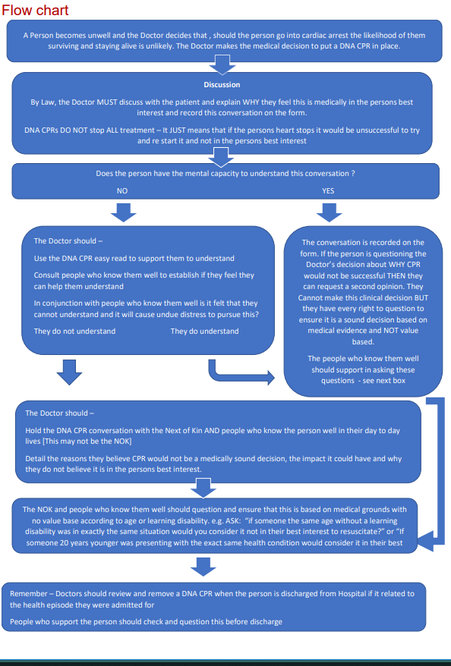

**Useful links**

**Bite-sized information about Learning Disability, mental capacity and decision making**

[Learning Disability Awareness for health Professionals No. 1 definitions](https://www.youtube.com/watch?v=UZNKRzQ6ae4&list=PLBSjtUxPa6TWumqvCbsz4V1kltGKo9gvb) You Tube videos

Video 9 is about mental capacity and best interest decisions and video 6 is about how the attitude of professionals can overcome barriers.

[Me on my best day](https://www.youtube.com/watch?v=oA-RP4JPmz8) video

[What is Cardio –Pulmonary Resuscitation (CPR) (hertfordshire.gov.uk)](https://www.hertfordshire.gov.uk/media-library/documents/adult-social-services/factsheets/easy-read/dnacpr-easy-read-leaflet.pdf) easy read information

**UK Resuscitation Council**

[CPR Decisions, DNACPR and ReSPECT](https://www.resus.org.uk/public-resource/cpr-decisions-and-dnacpr)

**Abbreviations**:

DNACPR or DNAR or DNR - Do Not Attempt Cardio-pulmonary Resuscitation

MCA - Mental Capacity Act

LPA - Lasting Power of Attorney

IMCA = Independent Mental Capacity Advocate

Credit: This guidance has been based on the document developed by the Turning Point and Learning Disability England.

**Talk about and Make a Pledge – Criteria 11**

Do all your patients with a learning disability who have a DNA CPR in place have clear wording that states Why CPR would not be successful and DOES NOT state that they have a learning disability?

Do they have a mental capacity assessment attached ?

Have you clearly evidenced the discussion with the person or key people in their life to explain the reasoning for this clinical decision?

**CRITERIA 12**

**Health Equality Targets**

* What does your practice do to follow up with DNAs and the 3 cancer screening pathways ?
* Do you engage with the cancer screening Health Equalities Learning Disability Nurse?
* Do all staff know what STOMP-LD is?
* What does your surgery do to ensure all relevant people have been referred to the STOMP Health Equalities Nurse?
* What do you do to identify those hard to reach patients on your learning disability register in your practice?
* Do all staff know how to engage with the Annual Health Check Health Equalities Nurse ?

**STOMP**

**What is STOMP?**

STOMP stands for Stopping Over Medication of People with a learning disability, autism, or both with psychotropic medicines. The overall goal is to help people stay well and improve their quality of life.

The reduction of long-term medication can be a huge challenge for GPs as carers and relatives are often reluctant to risk ‘rocking the boat’ and making reductions which can trigger a behaviour change [See the role of the STOMP nurses at the end of this section]

**What are Psychotropic medicines?**

Psychotropic medicines affect how the brain works and include medicines for psychosis, depression, anxiety, sleep problems and epilepsy. At times they are also given to people because their behaviour is seen as challenging.

People with a learning disability and/or autistic people are more likely to be given these medicines when compared to others. Although these medicines are right for some people and can help them stay safe and well, sometimes there are other ways of helping which involve less medicine or none at all.

Public Health England says that every day about 30,000 to 35,00 adults with a learning disability are taking psychotropic medicines when they do not have the health conditions the medicines are for.

**What are the side effects?**

Psychotropic medicines can cause problems if people take them for too long. Or take too high a dose. Or take them for the wrong reason. This can cause side effects like:

* Putting on weight
* Feeling tired or ‘drugged up’
* Serious problems with physical health

**Hertfordshire County Council**

HCC have s STOMP team who are working with GPs across the county to support reductions of medication for people with a learning disability who do not have a mental health diagnosis

The greatest challenge for GPs is to get people, the people who support them and their relatives to embrace trying to make a reduction. People are justifiably apprehensive about rocking the boat and risking behaviour changes.

The STOMP team work with everyone to complete a robust risk assessment, deep diving into their history and possible reasons medication was started. They then link with the GP to discuss the risks and recommendations and if a reduction is agreed the STOMP nurses supports throughout the reduction and enables carers to consider any behaviour changes as communication and develop positive behaviour plans to encourage positive communication.

For referrals and enquiries to the STOMP team, please email [**stomp@hertfordshire.gov.uk**](mailto:stomp@hertfordshire.gov.uk)

**Meet Trevor**

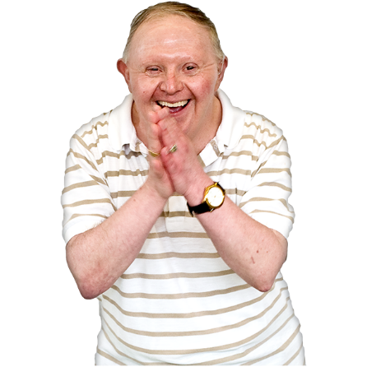Trevor is a man in his early 60’s who lives with his mum. His mum is in her 80’s so when the GP suggested at his annual health check, that they could try and reduce the use of Risperidone, his mum was very reluctant. She said she just wanted to live out her days looking after her son and if his behaviour escalated, she wouldn’t be able to.

The GP referred to the STOMP nurse, Charlie, who spent time meeting mum and Trevor and unpicking the history of how he started on the medication. Through the time spent on this risk assessment Charlie identified that Trevor’s behaviours started the same year as a relative moved into the house. Some years later it was identified that this person was abusive to Trevor, therefore, Trevor was potentially medicated because he was trying to communicate the abuse he was experiencing.

Through gentle work with mum, she then agreed to try and take him off the medication. Trevor is now no longer on the medication and mum has said “Thank you for giving me my son back. He is now walking purposefully to get things he wants, he is talking, laughing, and singing and he didn’t do any of these whilst on the medication”

Removal of Risperidone truly gave Trevor back his life and gave his mum her beloved son back.

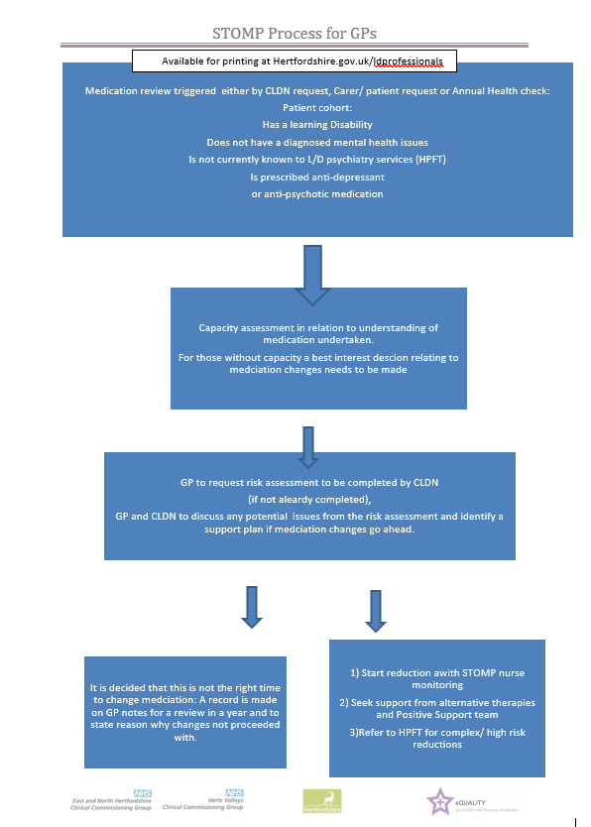**STOMP PROCESS**

**Cancer Screening**

Megan Roberts is the Health Equality Nurse for Cancer Screening. She supports people who are entering the screening process for the first time in cervical, breast and bowel cancer screening. She will assess individuals based on their capacity to understand the importance of screening and give them every opportunity to make an informed decision about the process. The key aim is to ascertain any reasonable adjustments that can be made to help the person to access the same service as those without learning disabilities.

**Bowel Screening**

Women and men are invited for **bowel screening aged 60**

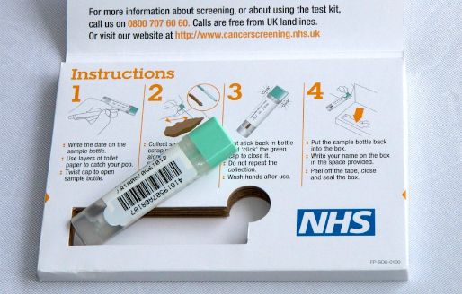Bowel Screening – age 60-74

if the individual has not had this call

0800 707 6060

[Bowel screening video - for person who supports someone with a learning disability](https://youtu.be/qzJ71-OY3t4)

[Bowel screening video for someone with a learning disability](https://youtu.be/qheY6Q0oifs)

**Cervical Screening**

Women are invited for **cervical screening (smear test) at aged 25**

[Cervical Screening test for people with learning disabilities](https://youtu.be/yQw4boPcKik)

This video is to help people understand what will happen and why the test is important.t

**Breast Screening**

Women are invited for **breast screening at aged 50**

[Breast Checking Guide](https://eur02.safelinks.protection.outlook.com/?url=https%3A%2F%2Fwww.hertfordshire.gov.uk%2Fmedia-library%2Fdocuments%2Fadult-social-services%2Ffactsheets%2Fbreast-checking-v1-30.9.22.pdf&data=05%7C02%7CEdi.Curran%40hertfordshire.gov.uk%7Cb843ea6ef313467e38bb08dc62e0d629%7C53e92c3666174e71a989dd739ad32a4d%7C0%7C0%7C638493965006040434%7CUnknown%7CTWFpbGZsb3d8eyJWIjoiMC4wLjAwMDAiLCJQIjoiV2luMzIiLCJBTiI6Ik1haWwiLCJXVCI6Mn0%3D%7C0%7C%7C%7C&sdata=eZc2UFGfNkkYDG3WXCn%2FlPyCq3MW%2FVMVokgQiPkIwuM%3D&reserved=0)

This is an easy read guide explaining breast screening in Herts.

**Meet Sarah**

When Megan contacted the GP practice for a list of ladies with a learning disability who were turning 25 and therefore would be invited for cervical screening for the first time, Sarah’s name was on the list as exemption coded. The practice said that this was at sarah’s mums request. This is not something that should happen as a parent cannot make a health decision on behalf of their adult child [unless they have LPA for health and Welfare] These decisions must be made as a clinical decision, checking capacity and then making a best interest decision if the person doesn’t have capacity to make this decision themselves.

Megan therefore contacted the family. Mum again said she didn’t want her daughter put through a smear so Megan explained that she needed to check Sarah’s capacity and if she didn’t have capacity then it would be the doctors decision, but the doctor would consider what mum thought was in Sarah’s best interest.

Megan met with sarah, showed her the cervical screening video and model and explained not just what would happen but also **WHY**. Sarah said she didn’t want it because she didn’t want her hair to fall out if she had cancer, so Megan explained that it isnt looking for cancer but is looking for changes that can be sorted before they turn to cancer. When Sarah heard that it is not looking for cancer and having the check can stop you from ever getting cancer she said ‘well im not going to get cancer if I can try and stop it’ and immediately accepted Megan booking her in with the practice nurse for her smear test.

Without this she would have stayed exemption coded and would never have had the opportunity to protect herself from cervical cancer.

**There are also other screenings that are important to check people aren’t missing out on!**

**Dementia Screening for People with Down Syndrome**

All people with Down syndrome who are aged 30, should be offered a DLD (Dementia Learning Disability) Assessment.

If there are patients on your register who fit this criterion, please refer to the Community Learning Disability Nurses (CLDNs) by using the GP [referral form](https://www.hertfordshire.gov.uk/media-library/documents/adult-social-services/ld-gp-referral-form.pdf) and send to the relevant team [below]

[watfordthreerivers.adt@hertfordshire.gov.uk](mailto:watfordthreerivers.adt@hertfordshire.gov.uk) 01442 454 343

[stalbans.adt@hertfordshire.gov.uk](mailto:stalbans.adt@hertfordshire.gov.uk) 01438 843 166

[dacorum.adt@hertfordshire.gov.uk](mailto:dacorum.adt@hertfordshire.gov.uk) 01442 454 444

[hertsmere.adt@hertfordshire.gov.uk](mailto:hertsmere.adt@hertfordshire.gov.uk) 01442 454 242

[welwynhatfield.adt@hertfordshire.gov.uk](mailto:welwynhatfield.adt@hertfordshire.gov.uk) 01438 843 600

[northherts.adt@hertfordshire.gov.uk](mailto:northherts.adt@hertfordshire.gov.uk) 01438 845 629

[Stevenage.adt@hertfordshire.gov.uk](mailto:Stevenage.adt@hertfordshire.gov.uk) 01438 845 529

[eastherts.adt@hertfordshire.gov.uk](mailto:eastherts.adt@hertfordshire.gov.uk) 01438 843 111

[Broxbourne.adt@hertfordshire.gov.uk](mailto:Broxbourne.adt@hertfordshire.gov.uk) 01438 843 400

[0-25_Central@hertfordshire.gov.uk](mailto:0-25_Central@hertfordshire.gov.uk) 01438 845 258

**AAA (Abdominal Aortic Aneurysm) Screening**

This is aone off screening for men in their 65th year - if the individual has not had this go online and look up local AAA screening.

This service has the Purple Star so are excellent at adjusting their service to help overcome barriers.

**Diabetic Eye Screening**

People are invitedannually from diagnosis – they too are a Purple Star service so will be able to make reasonable adjustments to overcome barriers .

**Talk about and make a pledge – Criteria 12**

What can your surgery do to check if anyone has not attended / completed any of the screenings they should have?

How can you follow up and make sure they understood the risks of not attending?

Can you link with the screening nurse for overcoming barriers?

Can you share the links to the videos to help people know what they need to do and why?

**CRITERIA 13**

**Training**

* What is the practices process to ensure all staff have the core training and understanding of the impact of their role on health inequalities for your patients with a learning disability?
* Have all clinicians involved in Annual Health Checks received the training related to this?
* Have all admin support involved in invitations and linking with your learning disability patients had the training relating to communication and the impact of their role?
* Have you developed pledges for practice change and recorded these?
* Does the LD champion have governence over enabling these pledges to be monitored and reviewed?

**This handbook and the embedded videos provides the core information for all staff to be learning disability aware in addition to your mandatory training. Here are all the videos referred to:**

|  |
| --- |
| **VIDEO LINKS – can all be found here:**  **Please subscribe to our channel**  [**community learning disability nursing service - YouTube**](https://www.youtube.com/channel/UCI_FEr3X73M---A_bpnxUnQ/videos) |
| * + **BITESIZE LEARNING DISABILITY AWARENESS VIDEOS** * [Definitions - The Difference between Learning Disability, Learning Difficulty and Autism](https://www.youtube.com/watch?v=UZNKRzQ6ae4&t=127s) * [Communication Barriers](https://www.youtube.com/watch?v=dQBmOsz9kCQ&t=2s) * [Your communication](https://www.youtube.com/watch?v=ioXQjktOe8o) * [Reasonable Adjustments – TIME](https://www.youtube.com/watch?v=_eIB8V-PF2A) * [Reasonable Adjustments – ENVIRONMENT](https://www.youtube.com/watch?v=6Cl2lqOhWEc) * [Reasonable Adjustments – ATTITUDE](https://www.youtube.com/watch?v=ad1oM4QcnoI) * [Reasonable Adjustments – COMMUNICATION](https://www.youtube.com/watch?v=_e3zefo4KzM) * [Reasonable Adjustments – HELP](https://www.youtube.com/watch?v=HqxtKVJX18I&t=131s) * [Capacity and Best Interest](https://www.youtube.com/watch?v=Mw40MeC9e6g) * [Helping people be more self-aware of their health](https://www.youtube.com/watch?v=2pJsjJe6tXE) * [Early spotting of possible safeguarding concerns](https://www.youtube.com/watch?v=UxWxNLKCe3Q) |
| * [Bristol stool chart explained](https://www.youtube.com/watch?v=9Wv87x9ho9s) * [Supporting someone with a learning disability to complete bowel screening](https://youtu.be/qzJ71-OY3t4) * [Bowel screening for someone with a learning disability](https://www.youtube.com/channel/UCI_FEr3X73M---A_bpnxUnQ) |
| * [what is autism](https://www.nhs.uk/conditions/autism/what-is-autism/) |
| * [Purple Folder Video](https://www.youtube.com/watch?v=ur7VQ6YqFaM) * [Me on my best day](https://www.youtube.com/watch?v=oA-RP4JPmz8) * [Be your own leader](https://youtu.be/HmJB3I9h3sc) * [Through our eyes](https://youtu.be/0_zOx88ZGZ0) * [TEACH rap](https://www.youtube.com/watch?v=eOIrV27P88Q) * [The handwashing rap](https://www.youtube.com/watch?v=4eY59qr2FTo) |
| * [Annual health check preparation tool](https://www.youtube.com/watch?v=6-fbmjaEWD0&t=193s) * [How to do a good annual health check](https://www.youtube.com/watch?v=lEEpias8OVA) |
| * [Preparing for healthy adulthood - chapter 1](https://www.youtube.com/watch?v=8qtcKDHK10M&t=380s) * [Preparing for healthy adulthood - chapter 2](https://www.youtube.com/watch?v=1K6YKHk_rYA) * [Preparing for healthy adulthood - chapter 3](https://www.youtube.com/watch?v=obFOuL33jCc) * [Preparing for healthy adulthood - chapter 4](https://www.youtube.com/watch?v=Lm1PnEHKObI) * [Preparing for healthy adulthood - chapter 5](https://www.youtube.com/watch?v=rmKDwXG44YY) * [Preparing for healthy adulthood - chapter 6](https://www.youtube.com/watch?v=x5LHrU-_nAw) |
| * [Gavin says 'Get your Covid-19 vaccination'](https://www.youtube.com/watch?v=3HRKQ-8eAIE) |
| * [Safeguarding](https://www.youtube.com/watch?v=UxWxNLKCe3Q&t=22s) |
| * [Reasonable Adjustments](https://www.youtube.com/watch?v=gUHHoZZcUTo&feature=emb_title) |

[**hertfordshire.gov.uk/ldprofessionals**](https://www.hertfordshire.gov.uk/services/adult-social-services/disability/learning-disabilities/my-health/professionals/information-for-professionals.aspx)

all new tools and information for GP practices are stored here

[**www.hertfordshire.gov.uk/ldmyhealth**](http://www.hertfordshire.gov.uk/ldmyhealth)

all information for people with a learning disability and the people that support them relating to health and learning disability nursing is stored here

**Talk about and make a pedge – Criteria 13**

What is your process for ensuring all staff are kept up to date?

How are your pledges and training monitored / overseen?

Is there anything you feel you can raise to your team on how this could be improved?

**CRITERIA 14**

**GP Link with learning disability nursing and specialist services**

* Do the team know who they can contact for support and advice relating to your patients with a learning disability?
* Do the team know the difference between the role of the specialist learning disability service in HPFT and the Community Learning Disability ursing Service in Adult Care Services?
* Do they know how to make a referral?
* Who does what to help you with your learning disability patients?

**The two areas of health service for people with learning disabilities are:**

1. **Communitity Learning Disability Nursing service** – under Adult Social Care [Refer via social Care].
2. **SLDS** – Specialist Learning Disability service – under HPFT [refer via SPA].

We work Closely together and have devised the following pathway to help you understand who does what. The basic summary is that referrals start with community learning disability nursing who focus on health inequalities and overcoming barriers, and are escalated to the specialist services if additional services are needed.

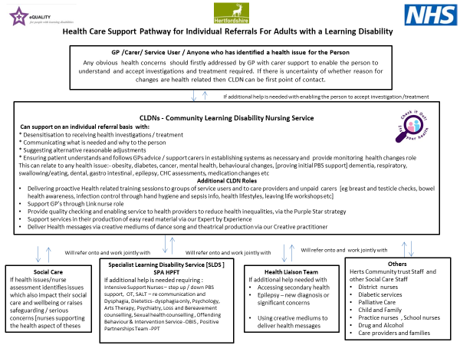

Within Learning Disability Nursing in Adult Social Care – we also have a number of specialisms – but again, we all work very closely together so can pass to our approriate nursing colleagues

**Here is an outline of the nursing service we offer and the contact details**

To make a referral to the Adult care nursing service – you need to visit our [Professional referral portal](https://hcsportal.hertfordshire.gov.uk/web/portal/pages/professionals) and create an account. Once an account has been created all referrals made can be reviewed and tracked from here. If you would like more information please read our professional referral portal guide.

**Hertfordshire County Council**

**Learning Disability Nursing Service**

Adult Care Service

**East**

Learning Disability Nurses in each Adult Disability Social Care Team working with people aged 25 or over

* East Herts
* Broxbourne
* North Herts
* Stevenage
* Welwyn and Hatfield

**Health Liaison Team**

**Countrywide**

* Strategic Liaison Nurse Leads
* Health Improvement & Prevention Team (HIP)
* Epilepsy Specialist Nurses (ESN)
* Acute Liaison Nurses (ALN)
* Training Lead
* Information Quality Officer
* Purple Star Strategy Team
* Creative Practitioner & Purple All-Stars
* Expert by Experience Advisor
* Health Equalities Nurses (HEN)

**West**

Learning Disability Nurses in each Adult Disability Social Care Team working with people aged 25 or over

* Dacorum
* Watford and Three Rivers
* Hertsmere
* St Albans

**0-25 Together**

**Countrywide**

Learning disability nurses work as part of this service but with people aged 18 – 25 only.

They can use all the additional nursing services under the Health Liaison Team and are also clinically overseen by the learning disability nurses in the Adult Disability Service

**Talk about and make a pledge – Criteria 14**

What do you now understand about the support available that you didn’t know before?

How will you make sure you and your practice engages with using the services available?

**CRITERIA 15**

**Feedback**

* Does everyone know how to seek feedback from patients and those that support them in an easyread format?
* Have you got links on your website?
* Do you give feedback to us for service improvement too?

**Feedback**

This section helps to embed “Ask Listen Do” for people with learning disabilities and their supporters.

In order for us to help create processes that work for you and for the people with a learning disability that are under your practice, we are constantly seeking feedback on the processes and on the practice.

This is so we can support you with any gaps in Ld awareness that may arise and also ensures we can keep your clinicians and staff up to speed with changes.

We also use the feedback from your surgery and your patients to shape change. For example the Purple Folder and the Annual health check prep form have both been rewritten based on the feedback received as we want to make sure processes work for everyone.

We get feedback via online forms, via you seeking permission for us to contact specific patients and carers directly and via carrying out a secret scoping call or visit, where someone with a learning disability contacts the practice. These all help us to be able to help you to reflect on your processes and practice and see if there are tweaks your team can make that could make all the difference to your patients with a Learning disability.

**Feedback is critical for us to develop our service and support we can offer to you!**

**Are you aware of the online feedback forms?**

For people working within a healthcare setting, carers and people with a learning disability to tell us what they think of our annual health check preparation form

.

Please pass this form on to anyone with a learning disability or someone who supports them to give feedback on the service they have received from you (the results will come straight to our inbox at Purple Star Strategy and you can request to see them at any time) [Online feedback form](https://surveys.hertfordshire.gov.uk/s/PurpleStarfeedback/)

[printable version of the feedback form](https://www.hertfordshire.gov.uk/media-library/documents/purple-star/purple-star-service-user-generic-feedback-form.pdf)

When making your annual health check calls and completing the core reasonable adjustment information, it is useful to then get their permission for us to contact them. We can then call those people to ask them directly for feedback.

We also visit all the carer and learning disability forums across Hertfordshire to gather feedback which we then share with practices.

We would like to engage your patient participation groups in having meaningful representation for people with learning disabilities – Consider how your PPG functions and what we may be able to do to enable better representation of this patient group and those that support them.

**Talk about and Make a Pledge – Criteria 15**

What can you do to help us gather more valuable feedback?

How can you use that feedback to influence practice?

Is there anything that can be done, with our support, to get representation on your patient participation Groups?

**The Purple All Stars**

As part of the Community Learning Disability Service in Hertfordshire, the Health Liaison Team employs a Creative Practitioner. Our Creative Practitioner uses creative arts to communicate and teach key health messages to people with a learning disability and their carers.

The people in this group form The Purple All Stars. They are supported by the Creative Practitioner to perform and share health messages through plays, song, and dance.

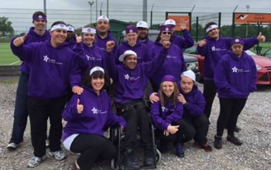

***The Following are some links to some of their creative pieces:***

**Be Your Own Leader**

A video created by the Purple All Stars and Kate Harding, Creative Practitioner. The Purple All Stars are a group of people with learning disabilities who provide powerful health promotion messages using creative arts. This song aims to educate people with learning disabilities to understand what they can do maintain a healthy life as well as send a message to health and care professionals as to their responsibilities.

[Be your own leader](https://youtu.be/HmJB3I9h3sc)

**Through Our Eyes**

A video about what it is like to have a learning disability and how much better and more successful an experience can be when reasonable adjustments are made.

[Through our eyes](https://youtu.be/0_zOx88ZGZ0)

**T.E.A.C.H Rap**

This is The Purple All Stars rap about reasonable adjustments and how to make them. This is aimed at embedding the message of what reasonable adjustments are and using the TEACH acronym to ensure all reasonable adjustments are made.

[TEACH rap](https://www.youtube.com/watch?v=eOIrV27P88Q)

**Purple All Stars Handwashing Rap**

A hand washing rap that illustrates good handwashing technique to prevent infections spreading.

[The handwashing rap](https://www.youtube.com/watch?v=4eY59qr2FTo)

**The Sepsis Song**

This is a catchy song to help people remember signs and symptoms of sepsis and learn that they should always ask ‘Could it be sepsis’?

[watch the sepsis song](https://www.hertfordshire.gov.uk/services/adult-social-services/disability/learning-disabilities/my-health/purple-all-stars.aspx" \l "sepsis)

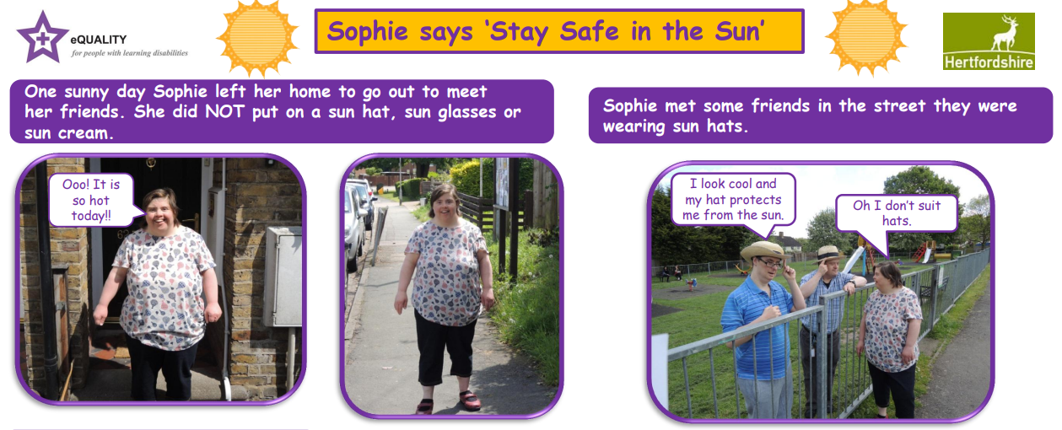**Stay Safe in the Sun**

A photo story about how to stay safe in the sun called ‘Sofie says Stay safe in the sun’…

[www.watfordmencap.org.uk/materials/**stay**_**safe_in_the_sun**.pdf](http://www.watfordmencap.org.uk/materials/stay_safe_in_the_sun.pdf)

**Gavin Explains TEACH**

Our Expert by Experience, Gavin, talking through his experience in health settings and how, by applying our acronym TEACH, his barriers have been overcome.

**Please contact us if you would like a copy.**

**Annual Health Check**

There is a video made by the clinical leads of both CCGs in Hertfordshire. It talks about the significance of a good annual health check and includes real life stories of how a good annual health check can enhance the quality of life. It tells a doctor what should be included in the Annual Health Check, the role of the Community Learning Disability Nurse and how reasonable adjustments should be made.

**Please contact us if you would like a copy.**

**Useful Websites and Telephone Numbers**

Information for people with learning disabilities – [www.hertfordshire.gov.uk/LDMyHealth](http://www.hertfordshire.gov.uk/LDMyHealth)

Information for professionals – [www.hertfordshire.gov.uk/LDProfessionals](http://www.hertfordshire.gov.uk/LDProfessionals)

**Help in the Community**

Advocacy services – [www.pohwer.net/](http://www.pohwer.net/) 0300 456 2370

Carers in Herts -[www.carersinherts.org.uk/](http://www.carersinherts.org.uk/) 01992 58 69 69

Herts Help - [www.hertshelp.net/](http://www.hertshelp.net/) 0300 123 4044

Health Watch - [www.healthwatch.co.uk/](http://www.healthwatch.co.uk/) 0300 068 3000

Safeguarding Adults -<http://www.hertfordshire.gov.uk/services/healthsoc/supportforadults/worriedabout/vulnadult/HSAB/>

<https://www.scie.org.uk/safeguarding/adults/>

Hertfordshire County Council - <http://www.hertfordshire.gov.uk/> 0300 123 4042

Hertfordshire Partnership Foundation Trust - [www.hpft.nhs.uk/](http://www.hpft.nhs.uk/)

NHS Patient advice and Liaison service - [www.hertfordshire.nhs.uk/.../pals.html](http://www.hertfordshire.nhs.uk/.../pals.html)

Mencap - [www.mencap.org.uk/](http://www.mencap.org.uk/) 0808 808 1111

**Easy Read/Signs and symbols**

Easy read health resources - [www.easyhealth.org.uk/](http://www.easyhealth.org.uk/)

Makaton - [www.makaton.org/](http://www.makaton.org/)

Photo Symbols – [www.photosymbols-cloud.com/](http://www.photosymbols-cloud.com/)

**Resources/Useful websites**

Mental Capacity Act - <https://www.gov.uk/government/collections/mental-capacity-act-making-decisions> A brief guide to the Mental Capacity Act (2005): Implications for people with learning disabilities.  Available from British Institute of Learning Disabilities [www.bild.org.uk](http://www.bild.org.uk) (£10.00) or as a free download at [www.scie.org.uk/mca/practice/care-planning/liberty-autonomy/](http://www.scie.org.uk/mca/practice/care-planning/liberty-autonomy/)

Mental Capacity consent pathway and Best Interest Decision pathway are available here <http://www.rcgp.org.uk/learningdisabilities>

<https://www.gov.uk/government/publications/reference-guide-to-consent-for-examination-or-treatment-second-edition> DoH reference guide to consent to examination and treatment

<https://www.gov.uk/government/collections/mental-capacity-act-making-decisions> Mental capacity Act 2005